- Setup jenkins CICD pipeline using freestyle job using Docker containers using below code.
https://github.com/betawins/hiring-app.git
Stages:
1) Git Clone
2) Sonarqube Integration
3) Maven Compilation
4) Nexus Artifactory
5) Slack Notification
6) Deploy On tomcat

STAGE 1 : GIT CLONE

1. Prerequisites

* Jenkins installed and running
* Jenkins Freestyle Job created
* Git installed on Jenkins server
* Jenkins server has internet access
* GitHub repository is public (or credentials added if private)

2. Step-by-Step Implementation

1. Open **Jenkins Dashboard**
2. Click **New Item**
3. Select **Freestyle Project**
4. Under **Source Code Management**

* Select **Git**
* Repository URL:
```
https://github.com/betawins/hiring-app.git
```
* Branch:
```
*/main
```
5. Save the job

3. Validation Steps

* Click **Build Now**
* Check **Console Output**
* Verify:

```
Cloning repository https://github.com/betawins/hiring-app.git
```
* Workspace should contain project files
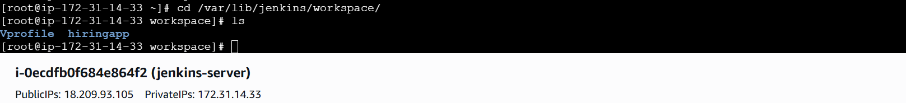
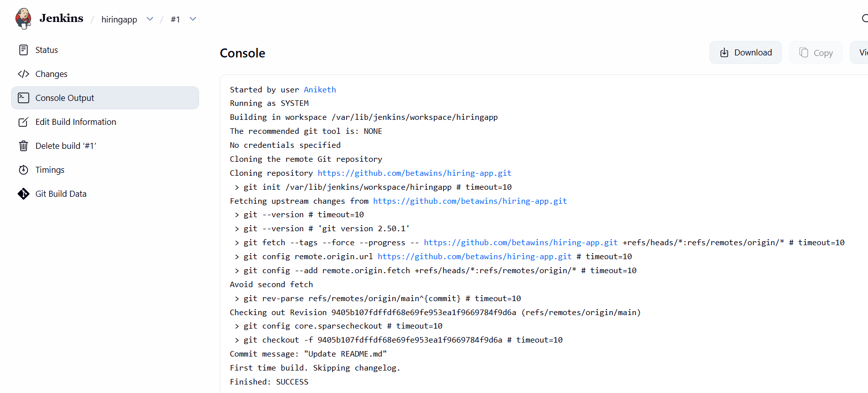

STAGE2: SONARQUBE INTEGRATION

1. Prerequisites

* SonarQube running (Docker or VM)
* SonarQube token created
* SonarScanner installed (or Docker image available)
* Jenkins configured with SonarQube server
* Java installed

- Step-by-Step Implementation

Sonarqube install by docker full guide :

## launch an instance with :: instance type=c7 flexi large , security groups allow 9000 port ,
Storage of 20gb.
## Login to server and run following commands .

yum -y install docker
systemctl start docker
docker pull sonarqube
docker images {to check available services}
docker run -itd -p 9000:9000 sonarqube
docker ps {to check which container running on portnumbers}

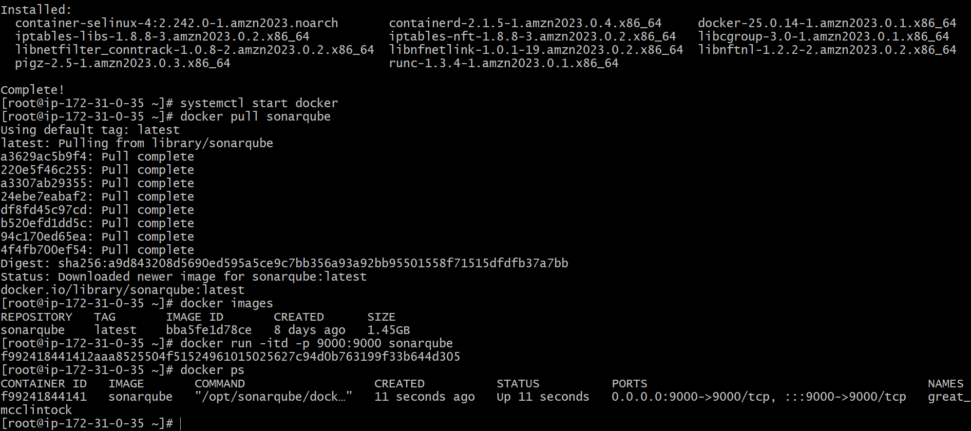
Succesfully sonarqube installed and running.

## Install sonar scanner on jenkins server
cd /opt
sudo yum install -y unzip
sudo wget https://binaries.sonarsource.com/Distribution/sonar-scanner-cli/sonar-scanner-cli-5.0.1.3006-linux.zip
sudo unzip sonar-scanner-cli-5.0.1.3006-linux.zip
sudo mv sonar-scanner-5.0.1.3006-linux sonar-scanner

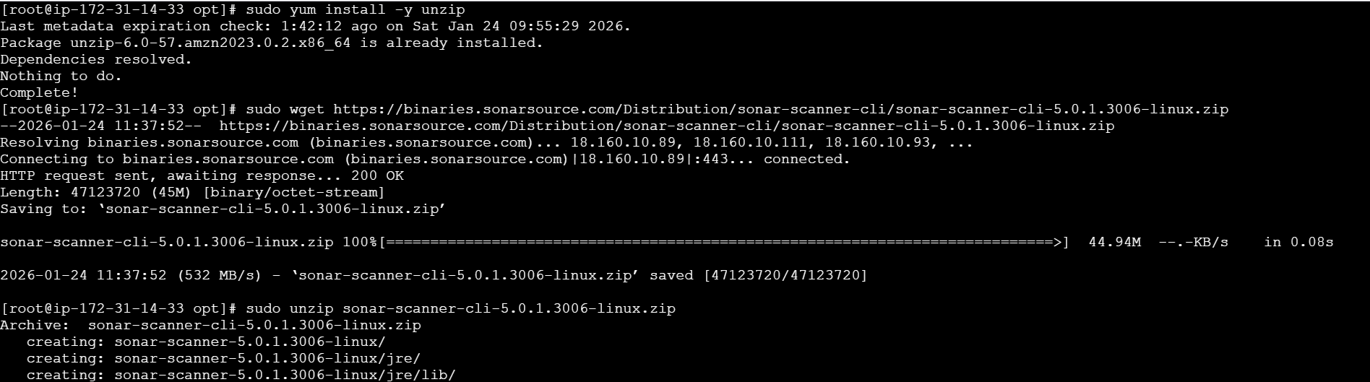

## Now change the config file of sonar-scanner

Cd /sonar-scanner/conf/sonar-scanner properties

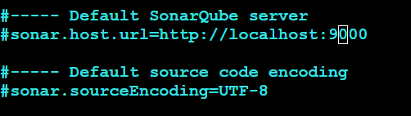

Add the url of sonarqube server and remove # in both lines

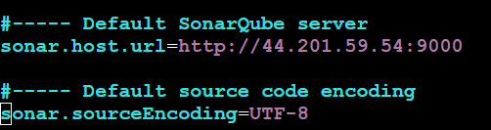

Save and exit.

## login to sonarqube by using url:9000

Initial default id and password for sonarqube is { ‘admin’ ‘admin’ }
After logging in update and change the password

## create a sonarqube token token
My account -- security -- token
Copy the token created.
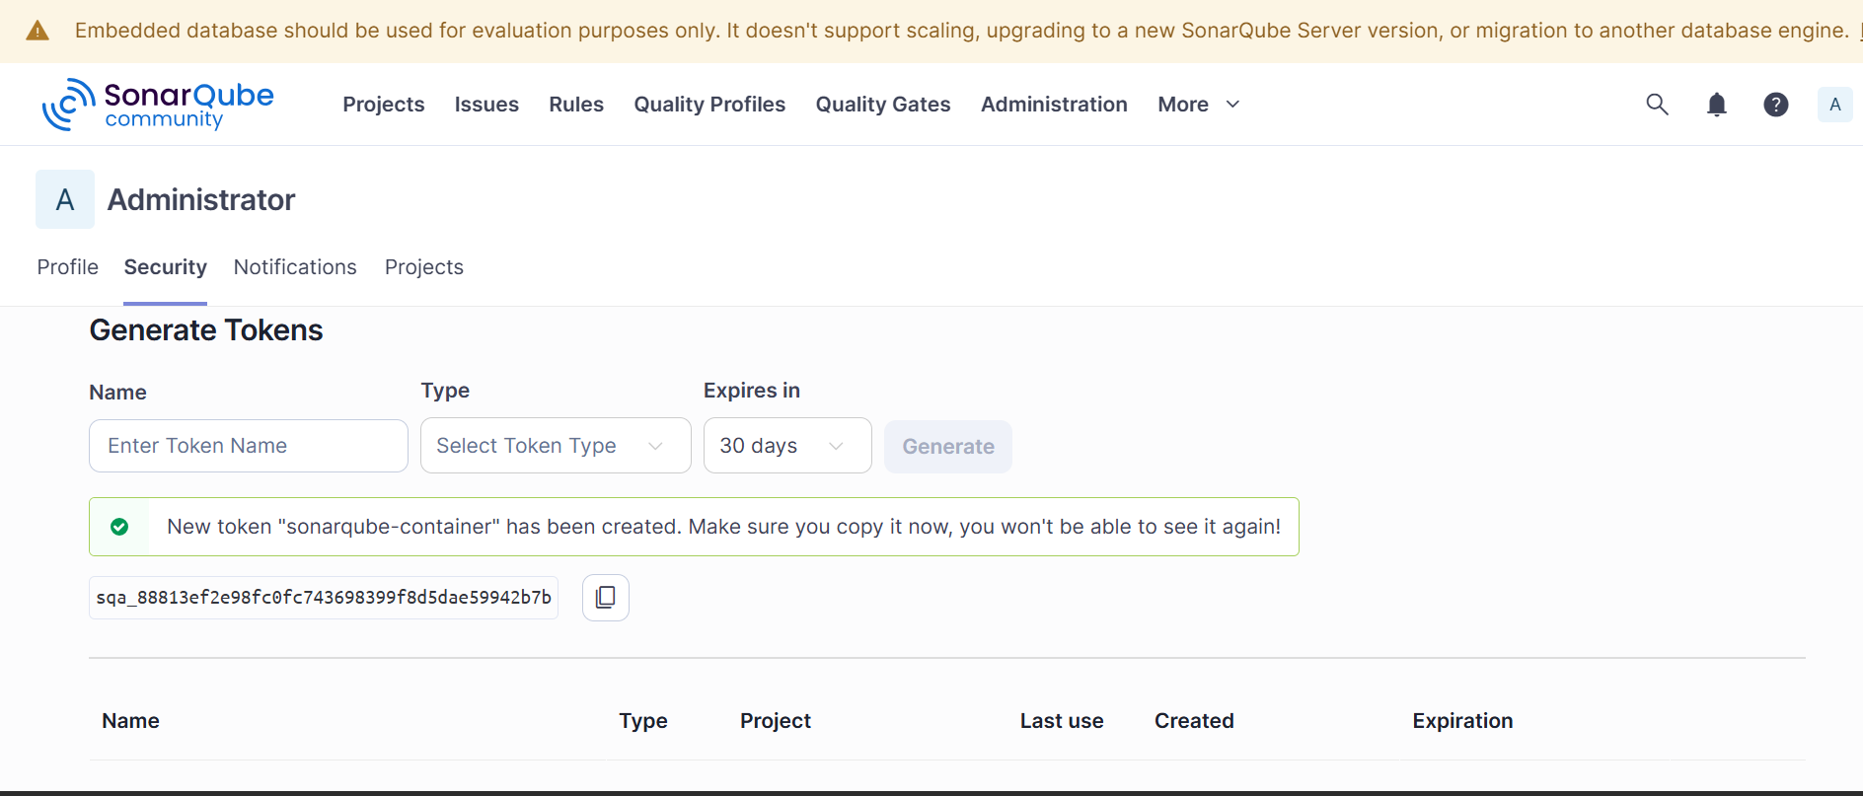

sqa_88813ef2e98fc0fc743698399f8d5dae59942b7b

## In jenkins GUI :

Install **SonarQube Scanner ** plugin in Jenkins

1. Manage jenkins --system--
Add sonarqube server
Name - sonarqube-server
Url - sonarqube-server url
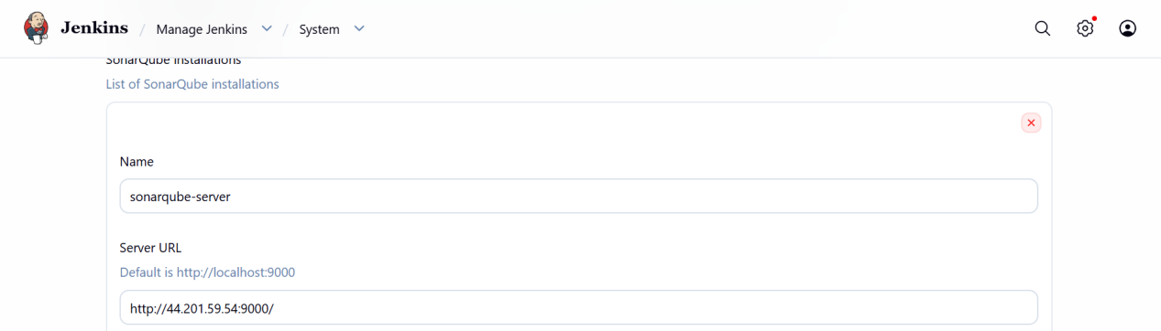

Token -
Add credentials - kind - secret text
Secret - paste copied token
Id - sonarqube-token
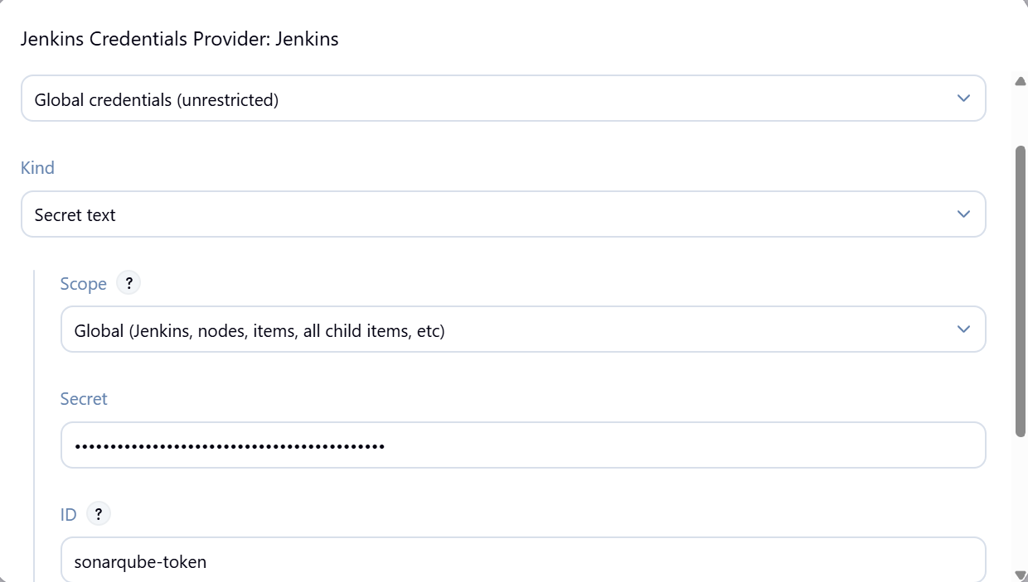
Save and select.

2. Manage jenkins -- tools
Add sonar scanner path
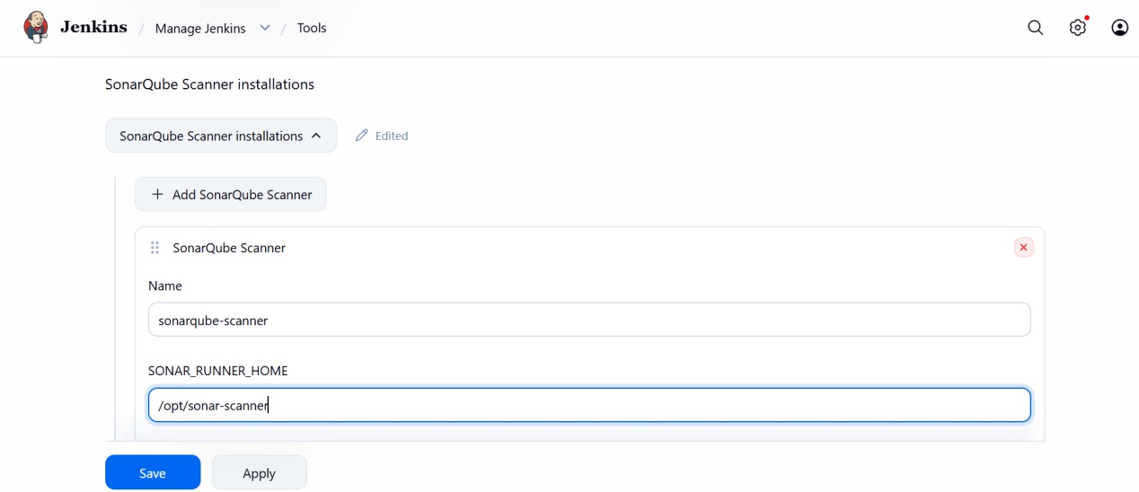

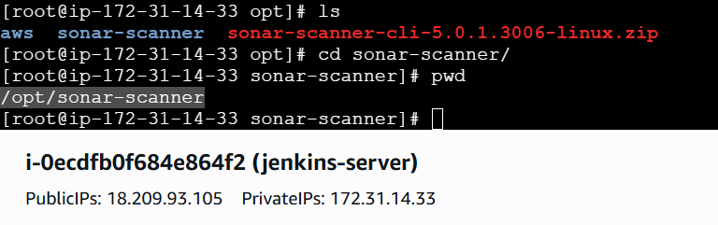
Sonarqube is ready.

Sonarqube-Integration

Select the job created > configure > build steps > execute sonarqube-scanner
Paste the analysis properties from readme.md.
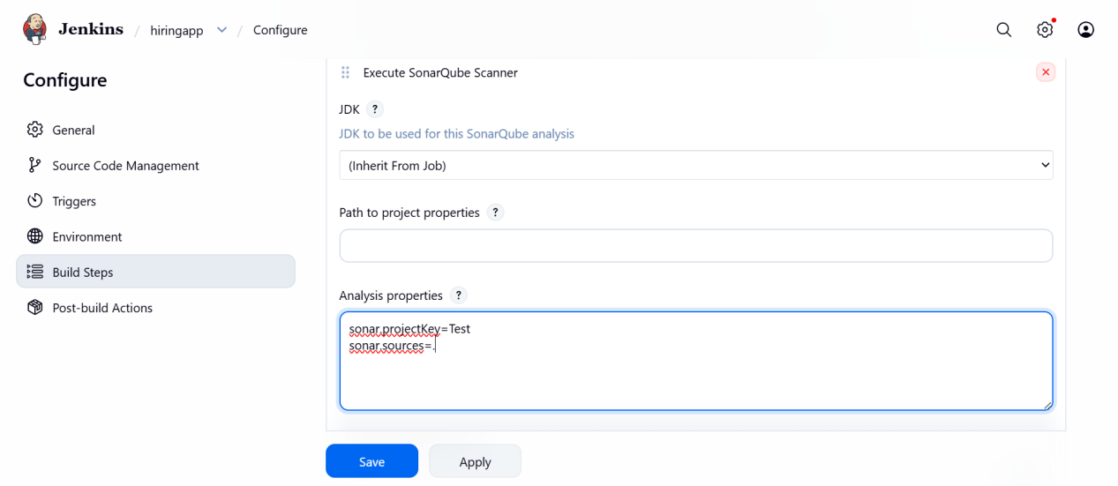
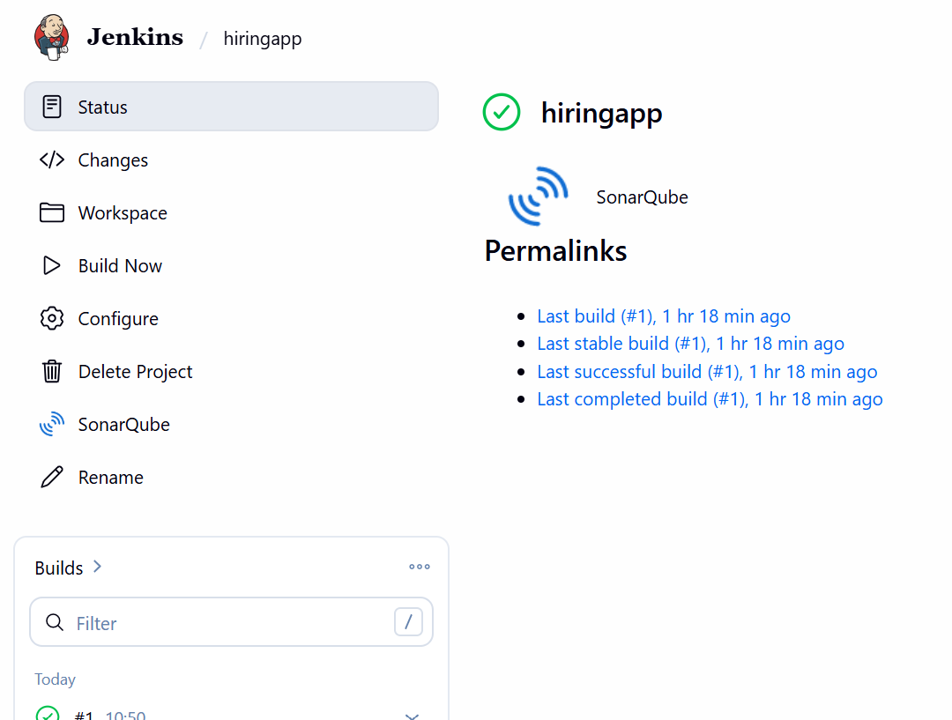

Save and build the job.

3. Validation Steps

* Build job
* Check SonarQube UI
* Project should appear with:

* Bugs
* Vulnerabilities
* Code Smells
* Quality Gate status

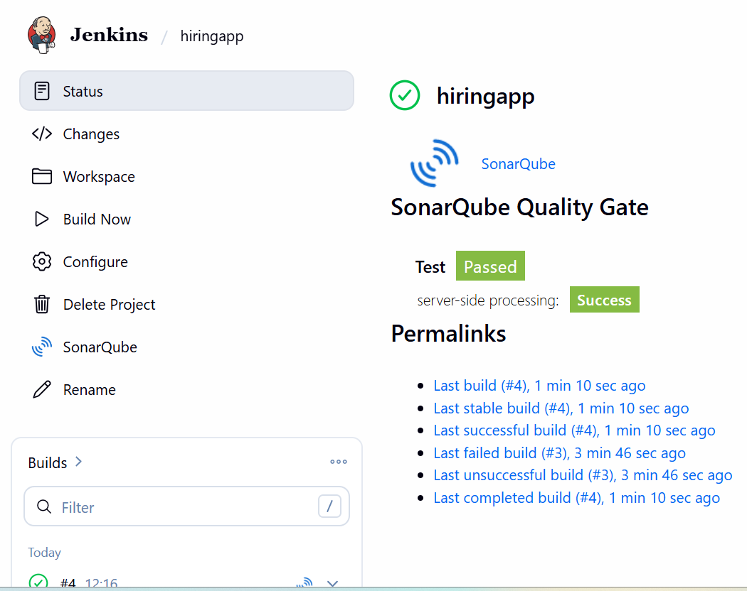

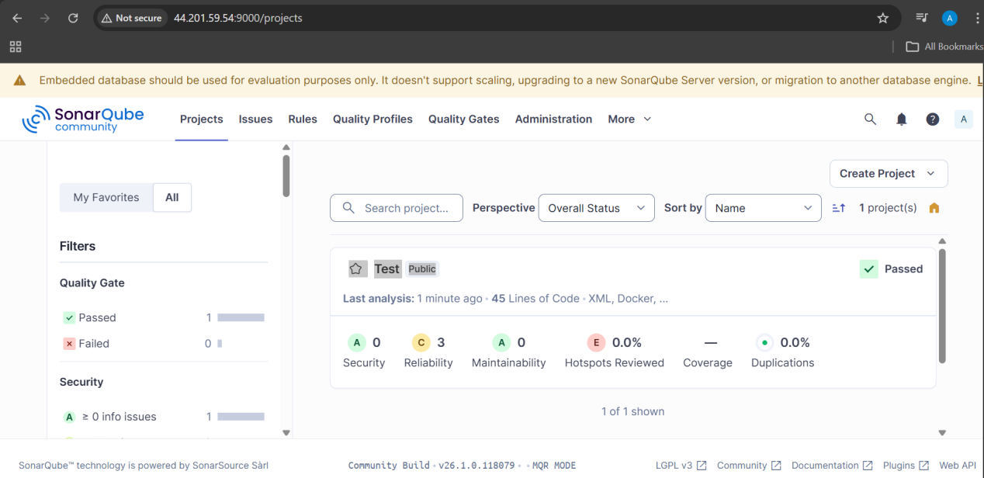

STAGE3: MAVEN COMPILATION

1. Prerequisites

* Maven installed on Jenkins
* Java JDK installed
* `pom.xml` present in repository

2. Step-by-Step Implementation

Maven istallation full guide :
In jenkins server : download maven , extract the tar file , in /opt location.
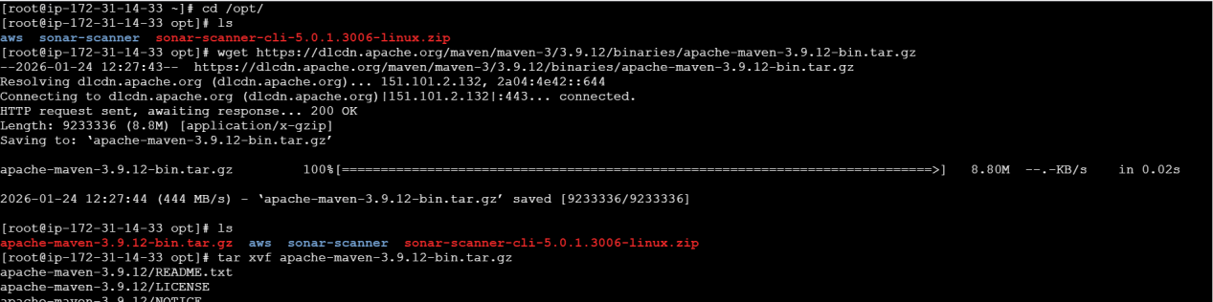
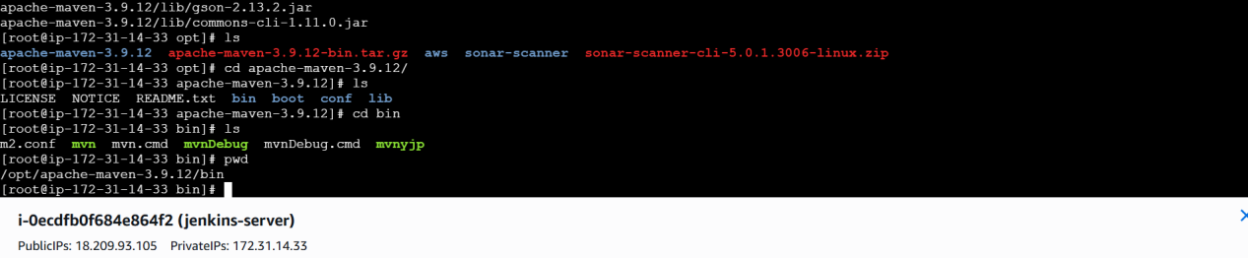

Export the global variables of maven in { .bash_profile}

MVN_HOME=/opt/apache-maven-3.9.12/bin
PATH=$PATH:$HOME/bin:$MVN_HOME

export path

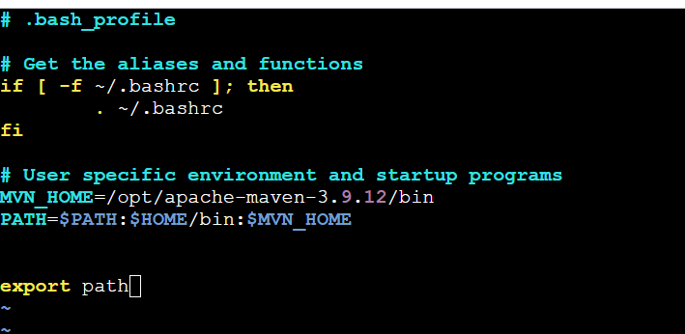

After editing , we need to restart the file using command
“source ~/.bash_profile”
Then we can check maven version

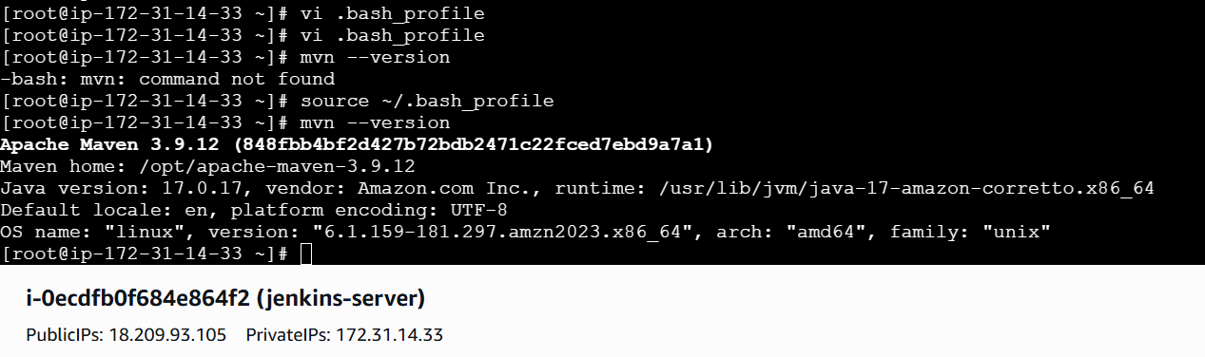

In Jenkins GUI : manage jenkins > tools > add maven

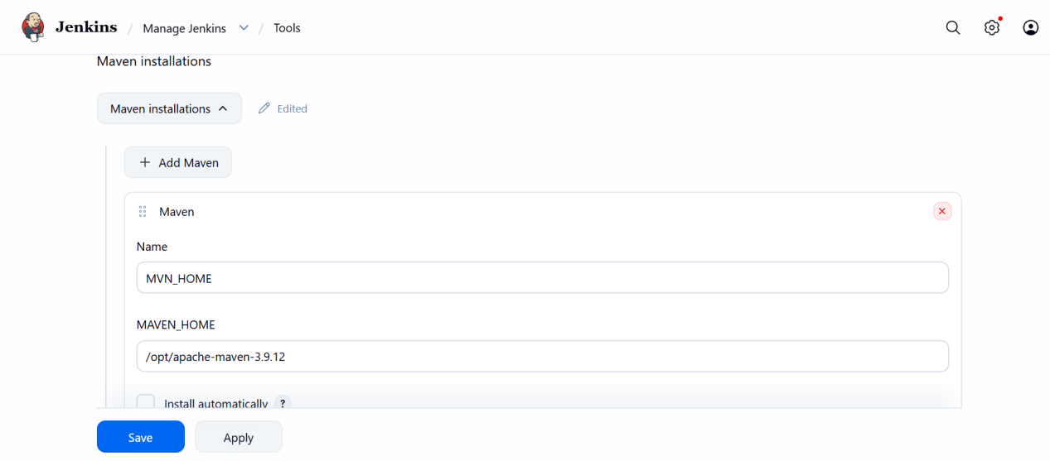
Maven is ready for integration.

Maven compilation :

Go to jenkins job > configure > build steps > invoke top level maven targets

select maven version and goals as “ clean install ”

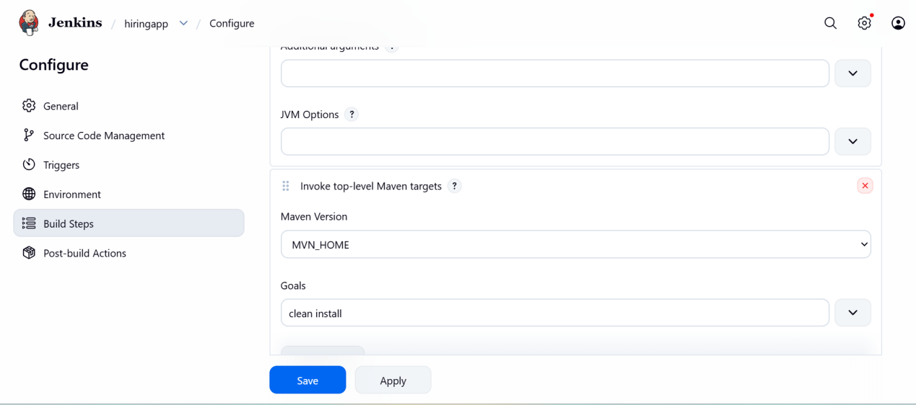

Save and build job .

3. Validation Steps

* Console Output should show:
```
BUILD SUCCESS
```
* WAR file generated:
```
/var/lib/jenkins/workspace/job/target/hiring-app.war

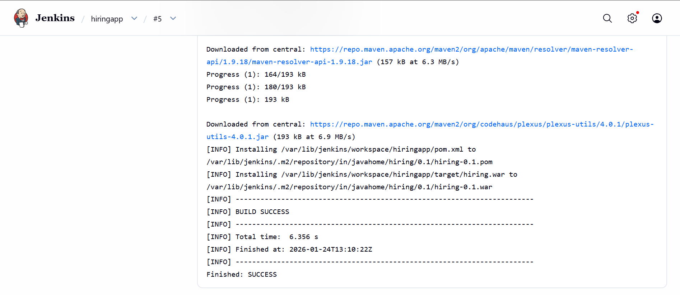
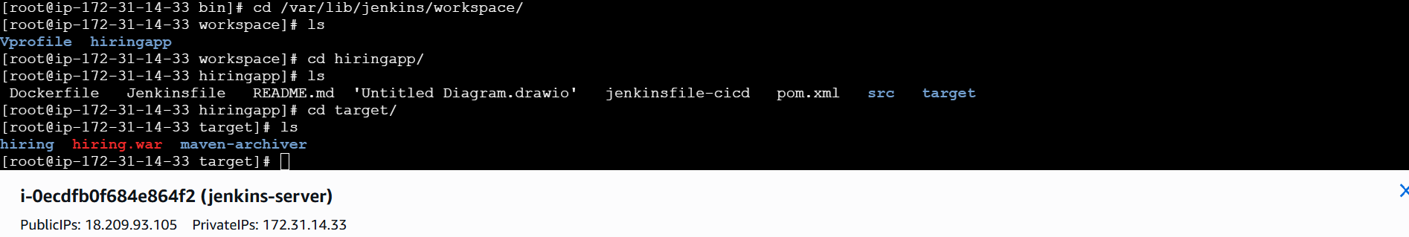

* The war file naming got from pom.xml >> of artifactid,version,packaging.
* The dependencies of maven are downloaded in .m2 directory
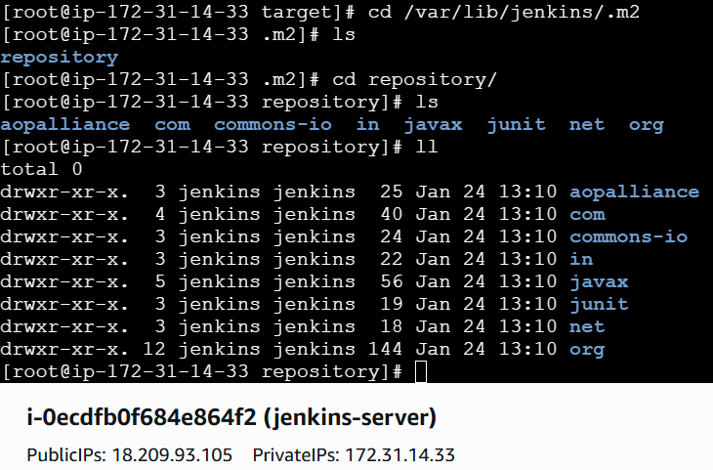

STAGE 4 : NEXUS ARTIFACTORY

1. Prerequisites

* Nexus Repository Manager running
* Maven hosted repository created
* Nexus credentials available
* `distributionManagement` configured in `pom.xml`

2. Step-by-Step Implementation

NEXUS INSTALLATION FULL GUIDE :

## launch one instance , instance type =c7 flexi large ,security groups = 8081 port open ,

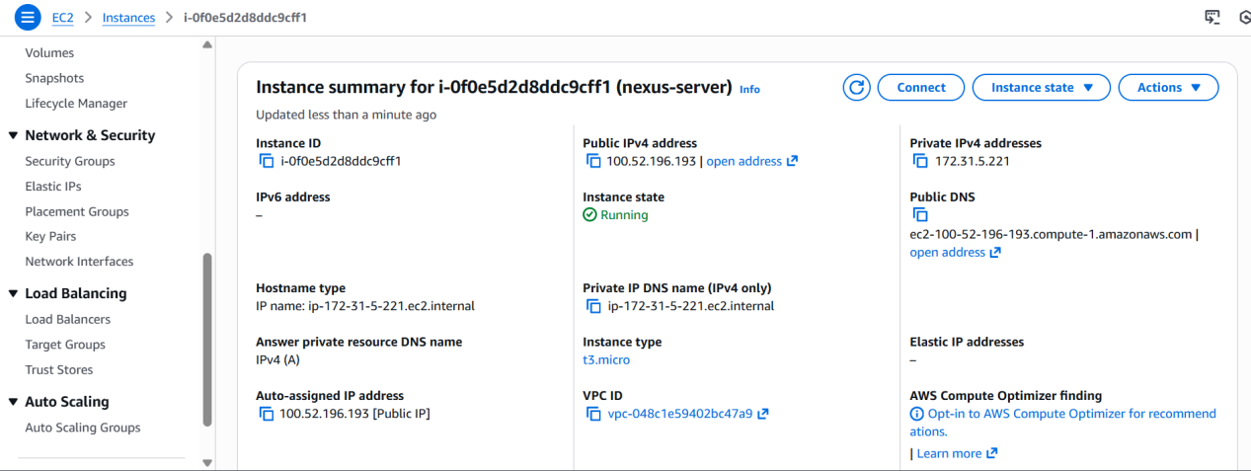

## install java latest version :
sudo yum update -y
sudo dnf install java-17-amazon-corretto -y
java -version

## download nexus in /opt :

cd /opt
wget https://download.sonatype.com/nexus/3/nexus-3.88.0-08-linux-x86_64.tar.gz
tar xvf nexus-3.88.0-08-linux-x86_64.tar.gz
mv nexus-3.88.0-08 nexus

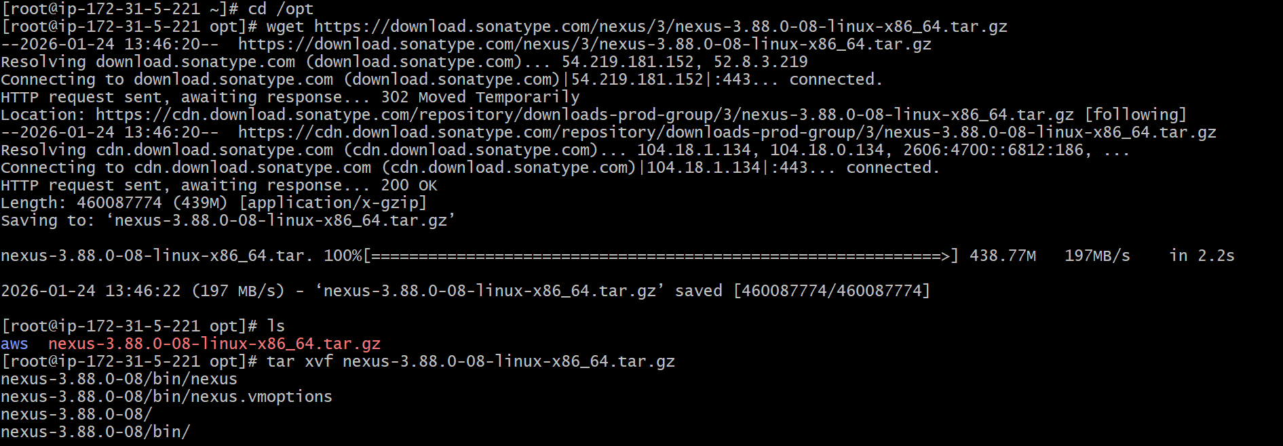
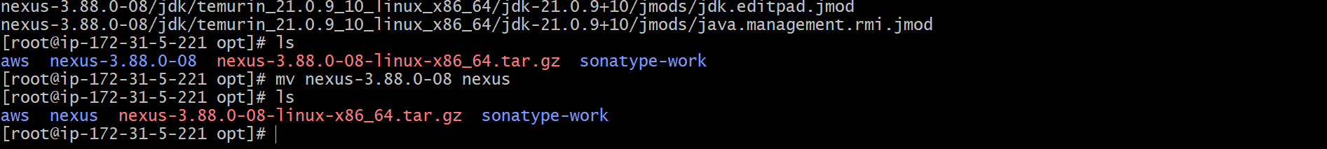

## create user nexus , and ownership to nexus and switch to the created user.

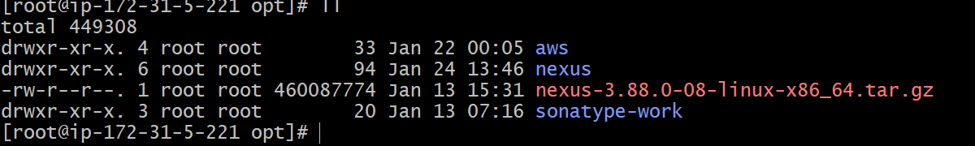
sudo useradd nexus
sudo passwd nexus
sudo chown -R nexus:nexus /opt/nexus
sudo chown -R nexus:nexus /opt/sonatype-work

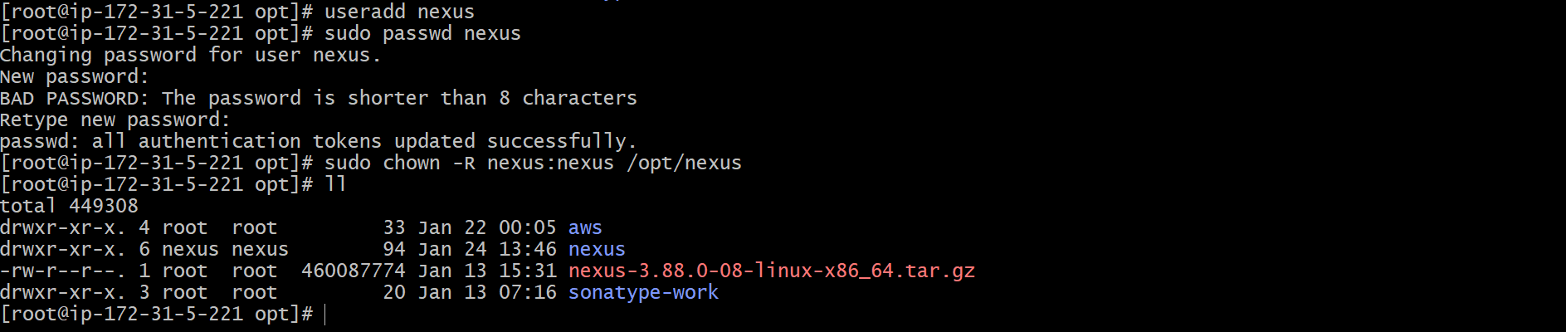
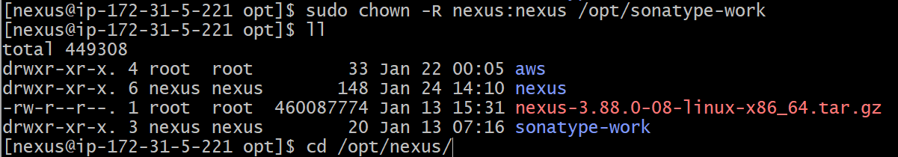

Adding user nexus to sudoers file

sudo vi /etc/sudoers.d/nexus
>>> nexus ALL=(ALL) NOPASSWD:ALL
sudo chmod 440 /etc/sudoers.d/nexus

## open nexus runtime configeration file{nexus.rc} ,

Vi /opt/nexus/bin/nexus.rc
•Set: run_as_user="nexus"
•This ensures Nexus runs under the nexus user instead of root
•Saved and exited the file
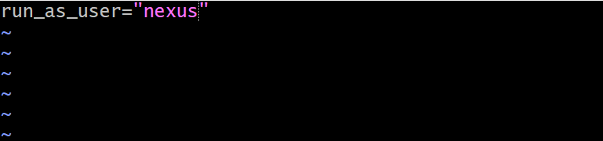

## switch to user nexus and start the nexus:

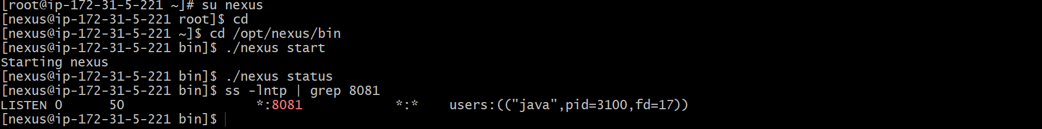

## login to nexus repository :

http://<public-ip>:8081

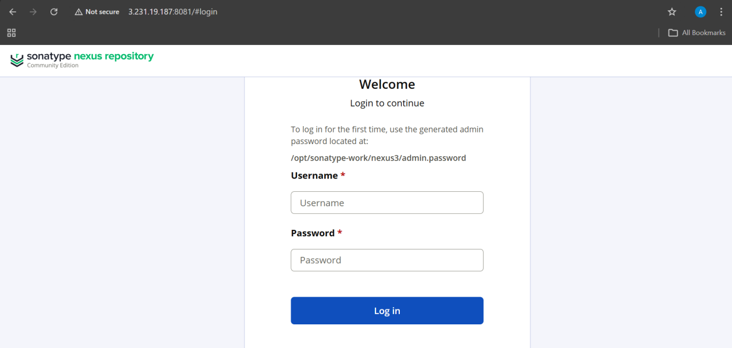

User name is admin and password we can find it from above

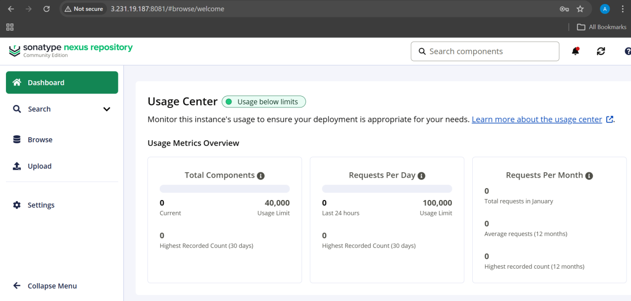

•Successfully logged into Nexus Repository Manager.
•Nexus dashboard loaded.
## install the plugin “nexus artifact uploader”

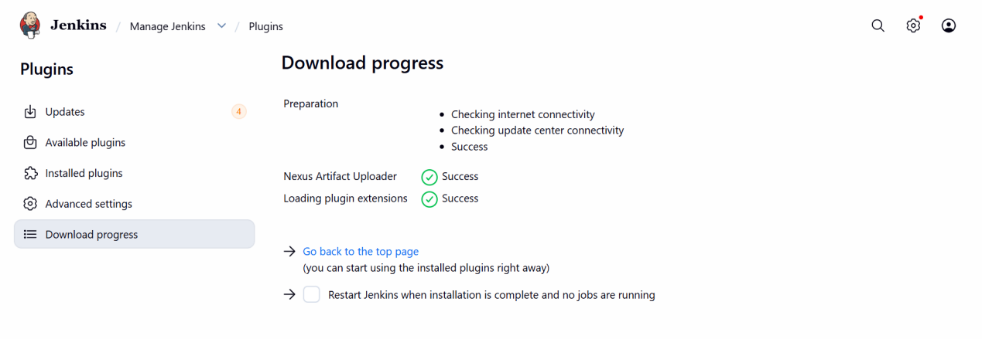

Nexus-artifactory integration on jenkins :

Go to jenkins job >>configuration>>build steps>>nexus artifact uploader

Nexus details ==

Nexus version - nexus3
Protocol - http
Nexus url - paste the url of nexus-server
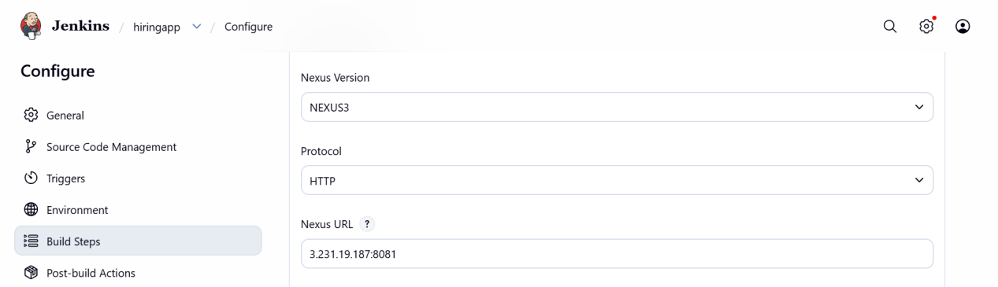

Credentials - click add >> create new credentianls with username and password of nexus repository.

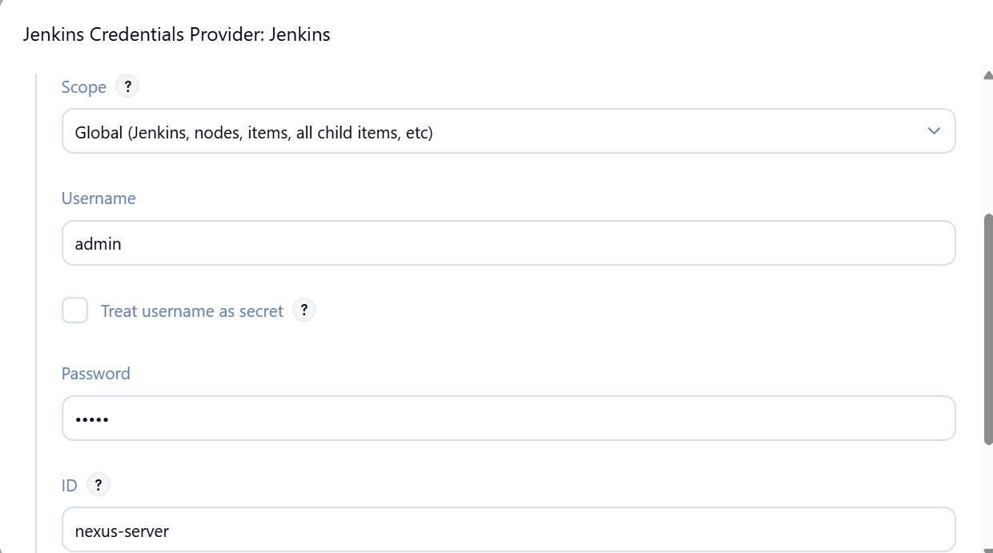

Group id - it can be found in pom.xml of project.
Version - it can be found in pom.xml of project.
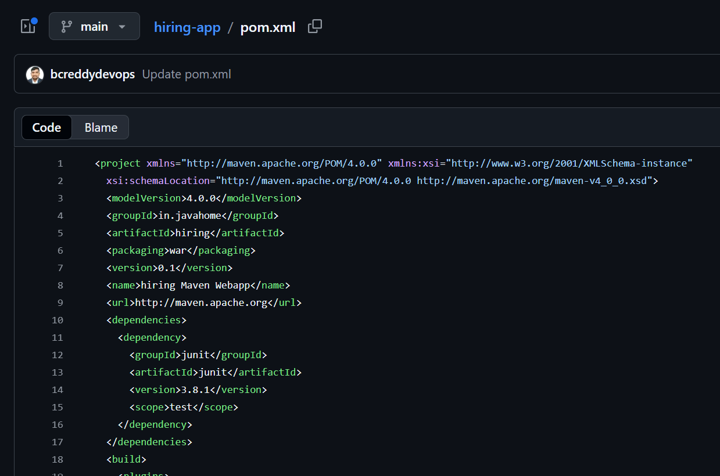

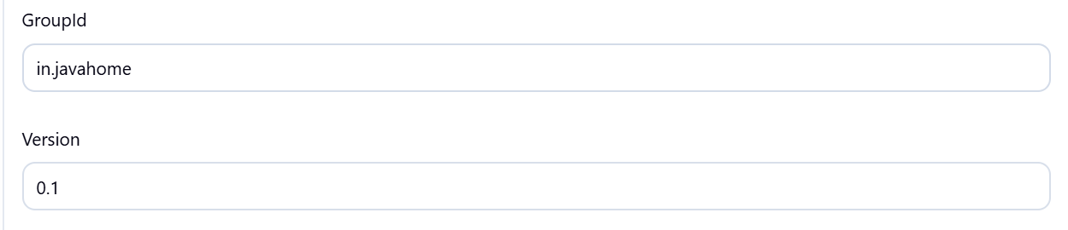

Repository - add the created repository name.
create a repository in nexus , of recipie :maven2 hosted ,
Name : job name
Version : release
Layout policy : permissive
Blob storage : default
Deploy policy : allow
Note: we need to create repository as per requirement of versions like release ,snapshot ,

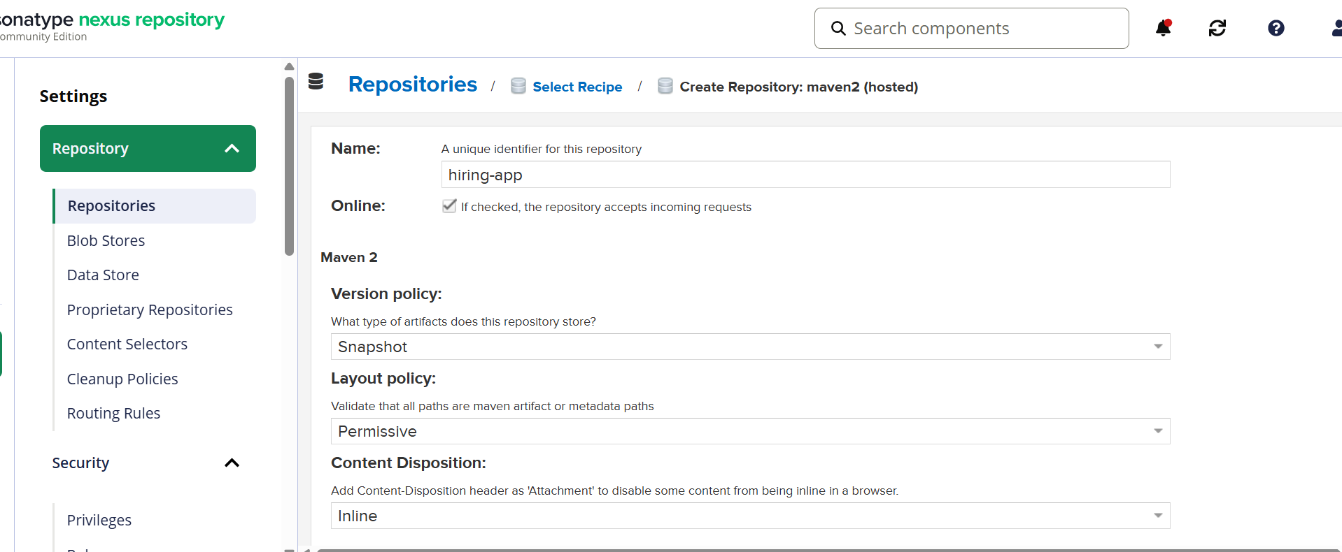

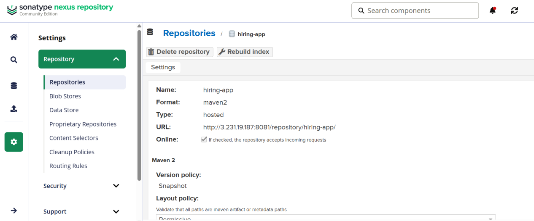

Add artifacts details :

Artifactid - from pom.xml
Type - packaging from pom.xml
Classifier : ignore
File : path location of war file created by maven.
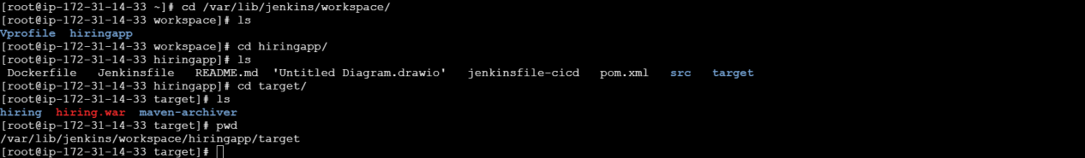
Here file path is : /var/lib/jenkins/workspace/hiringapp/target/hiring.war

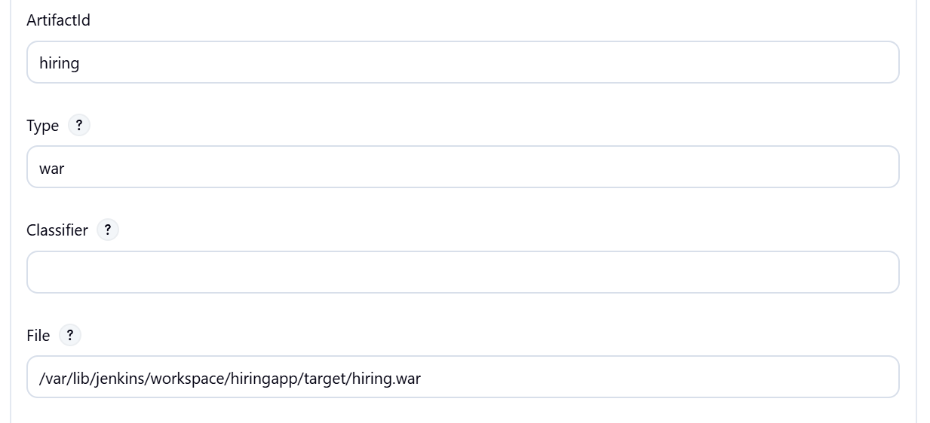

Build the job.

3. Validation Steps

* Login to Nexus UI
* Navigate to **Browse → hiringapp**
* Artifact should be visible with version
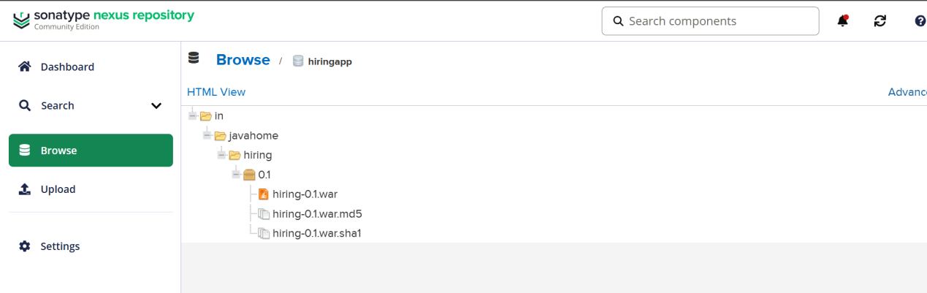

STAGE 5 : SLACK INTEGRATION

In jenkins install plugin “global slack notifier”

Go to slack in browser >> more>> tools>> apps >> jenkins ci >> configure >> add to post channel

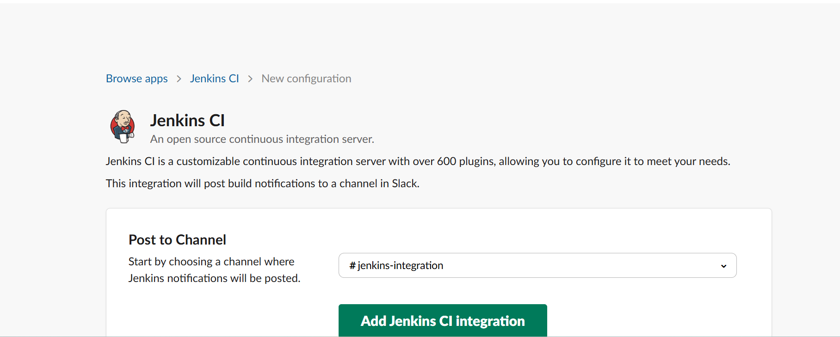

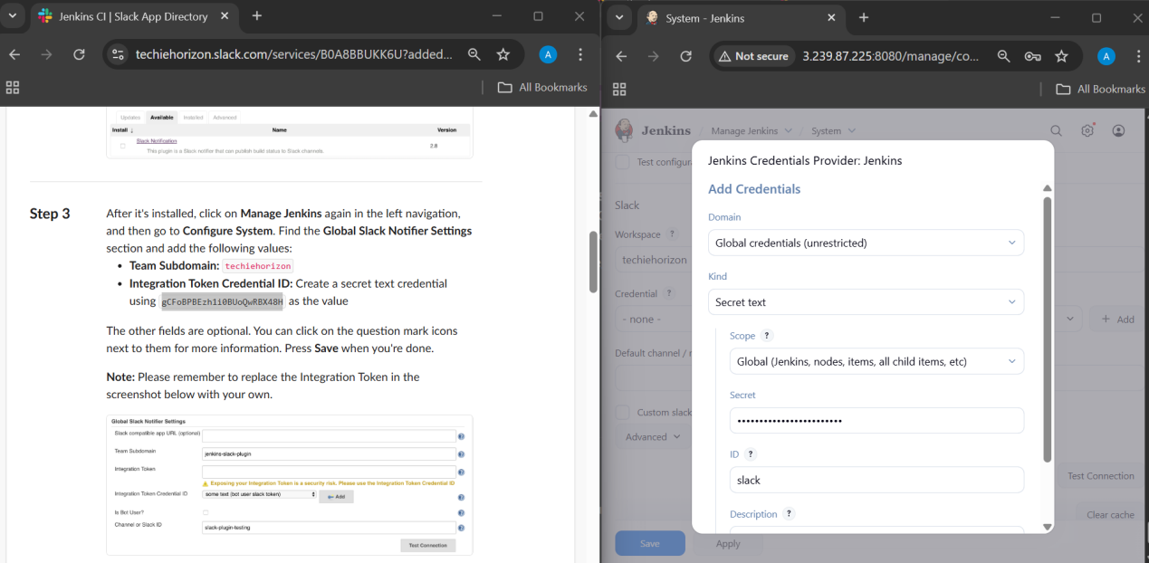

In jenkins GUI :
Manage jenkins >> system >> slack

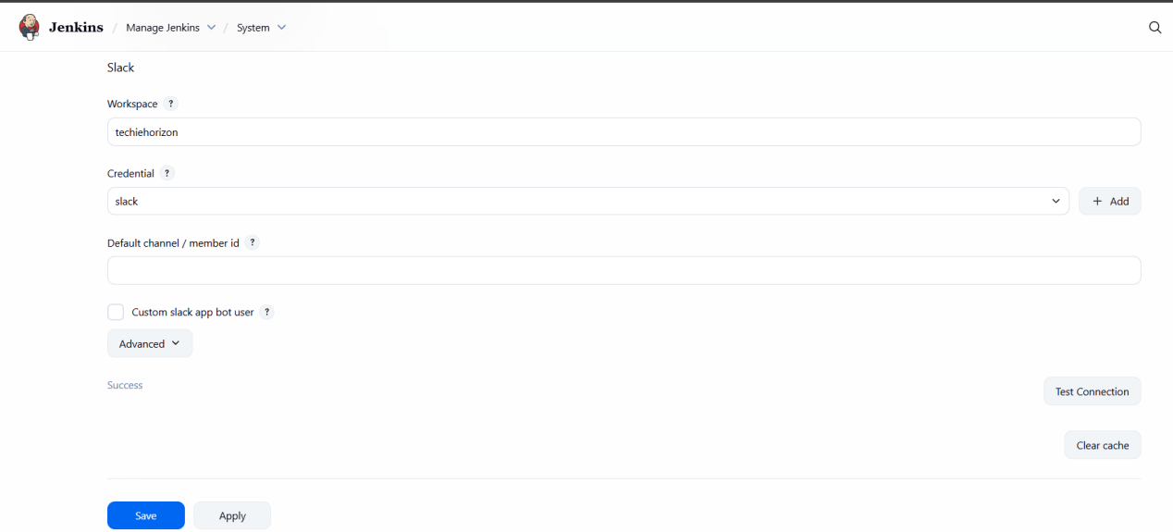

In job configure >> post build actions >> slack notification

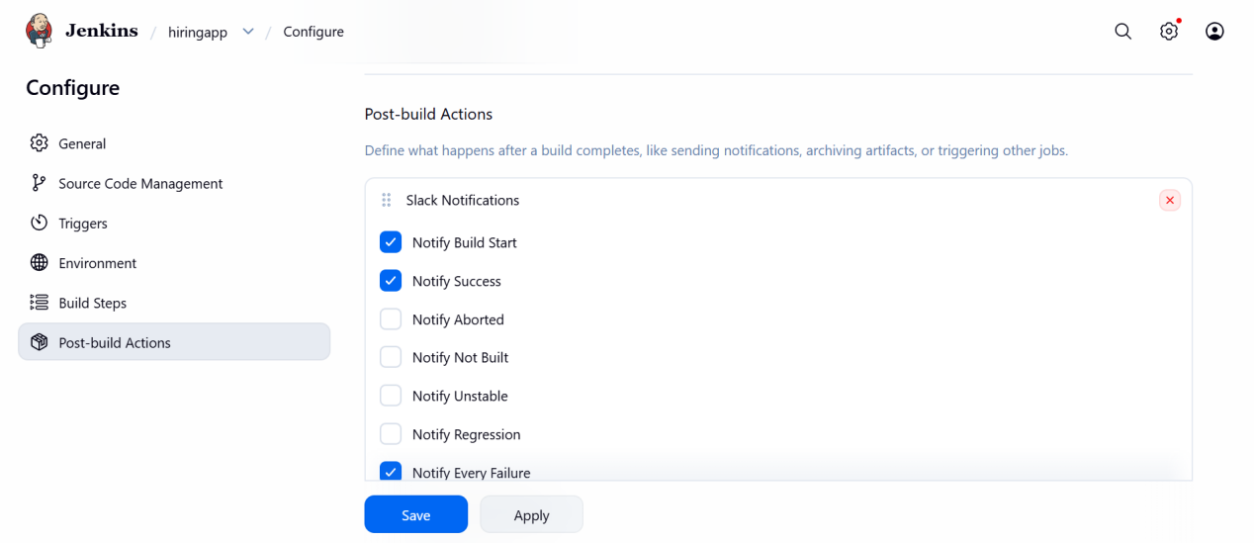

Succesfully slack notifications jenkins integration done.

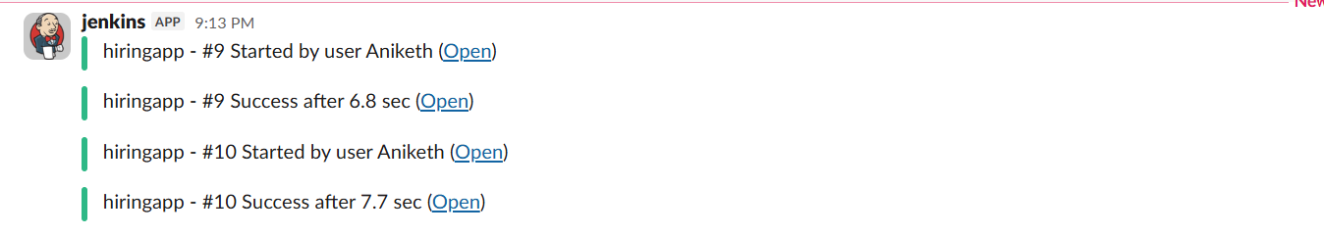

STAGE 6 : DEPLOY ON TOMCAT

1. Prerequisites

* Tomcat server
* Port 8080 accessible
* WAR file built successfully
* Install plugin “deploy to container”.

2. Step-by-Step Implementation

Tomcat Installation full guide for deployment :

## launch an ec2 instance , instance type:c7flexi-large , ports 8080 open .

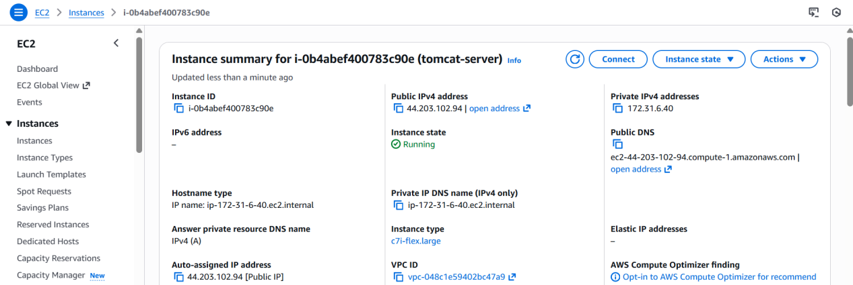

## login to instance , install java and tomcat :

sudo dnf update -y
sudo dnf install java-17-amazon-corretto -y
java -version

Tomcat download :
cd /opt
wget https://dlcdn.apache.org/tomcat/tomcat-9/v9.0.115/bin/apache-tomcat-9.0.115.tar.gz
tar xvf apache-tomcat-9.0.115.tar.gz
cd apache-tomcat-9.0.115
cd bin
bash startup.sh
Tomcat started succesfully . >> http://<tomcat-public-ip>:8080 .
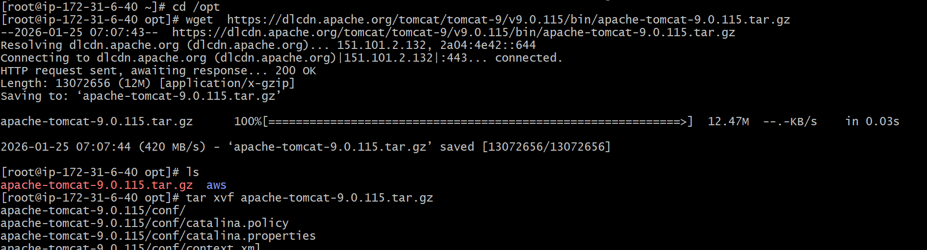
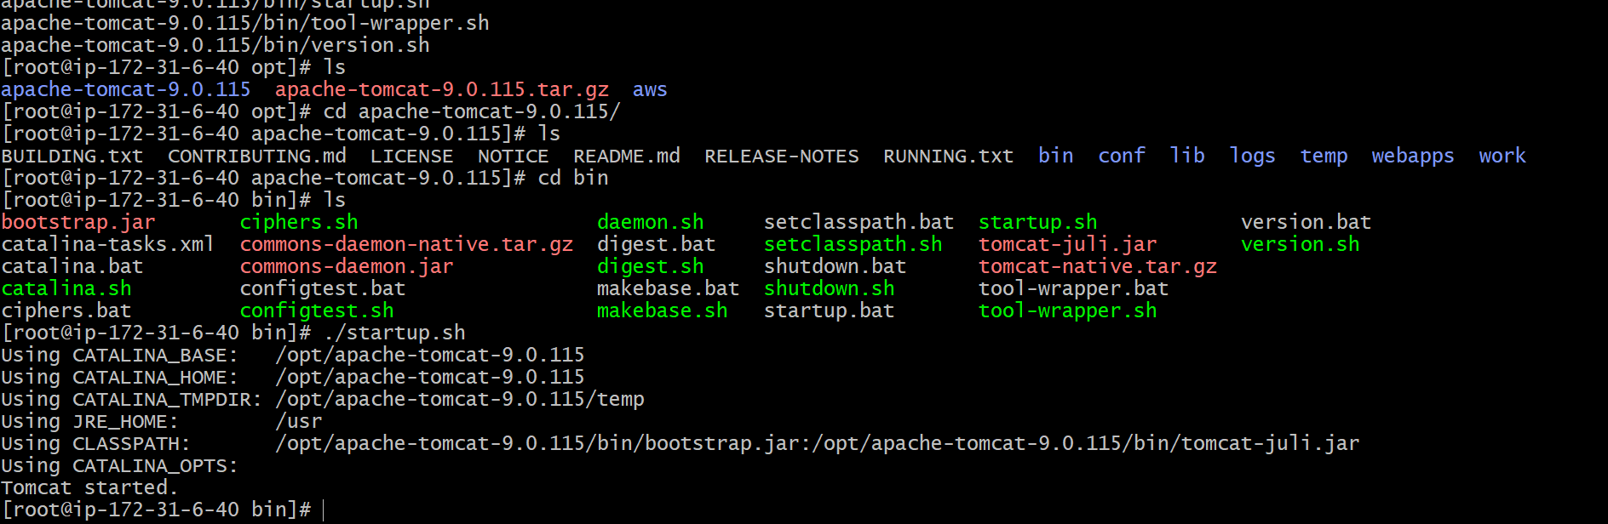

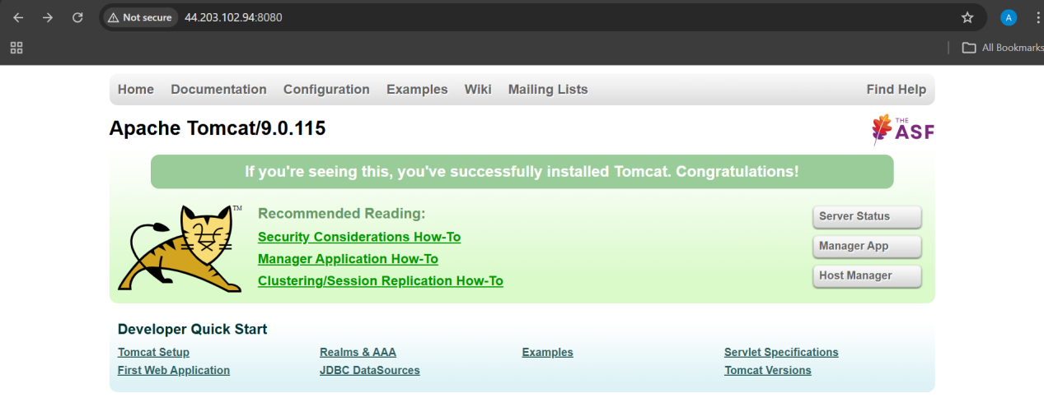

## search for context.xml :

find / -name context.xml

above command gives 4 context.xml files.
comment (<!-- & -->) `Value ClassName` field on files which are under webapp directory.
After that restart tomcat services to effect these changes

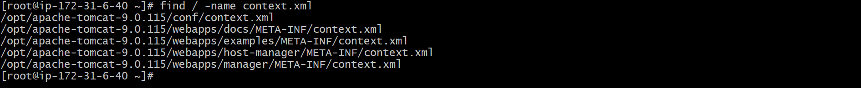

vi /opt/apache-tomcat-9.0.115/webapps/docs/META-INF/context.xml

Comment at valve class name
Save and exit.

vi /opt/apache-tomcat-9.0.115/webapps/examples/META-INF/context.xml
Comment at valve class name
Save and exit.

vi /opt/apache-tomcat-9.0.115/webapps/host-manager/META-INF/context.xml
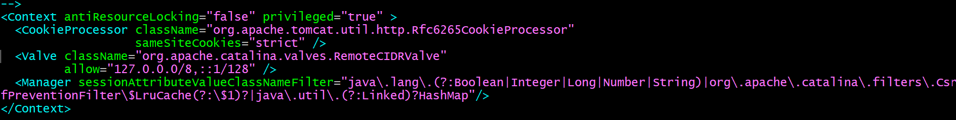
Comment at valve class name
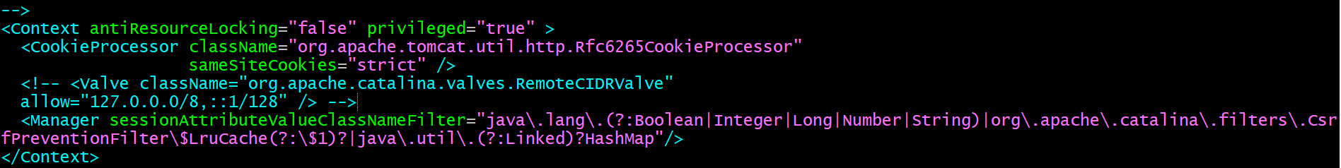
Save and exit.

vi /opt/apache-tomcat-9.0.115/webapps/manager/META-INF/context.xml
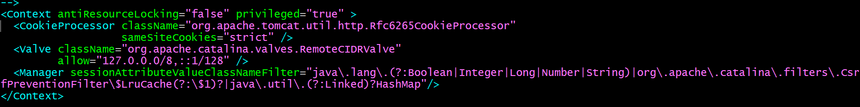
Comment at valve class name
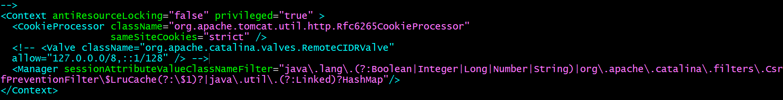
Save and exit .

## Update users information in the tomcat-users.xml file :
goto tomcat home directory and Add below users to conf/tomcat-user.xml file
```sh
<role rolename="manager-gui"/>
<role rolename="manager-script"/>
<role rolename="manager-jmx"/>
<role rolename="manager-status"/>
<user username="admin" password="admin" roles="manager-gui, manager-script, manager-jmx, manager-status"/>
<user username="deployer" password="deployer" roles="manager-script"/>
<user username="tomcat" password="s3cret" roles="manager-gui"/>
```
Restart serivce and try to login to tomcat application from the browser.

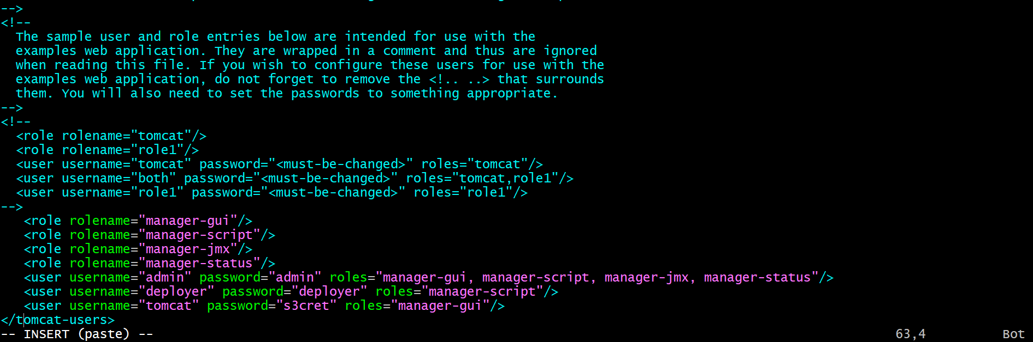
Save and exit .
Restart the tomcat to apply changes.
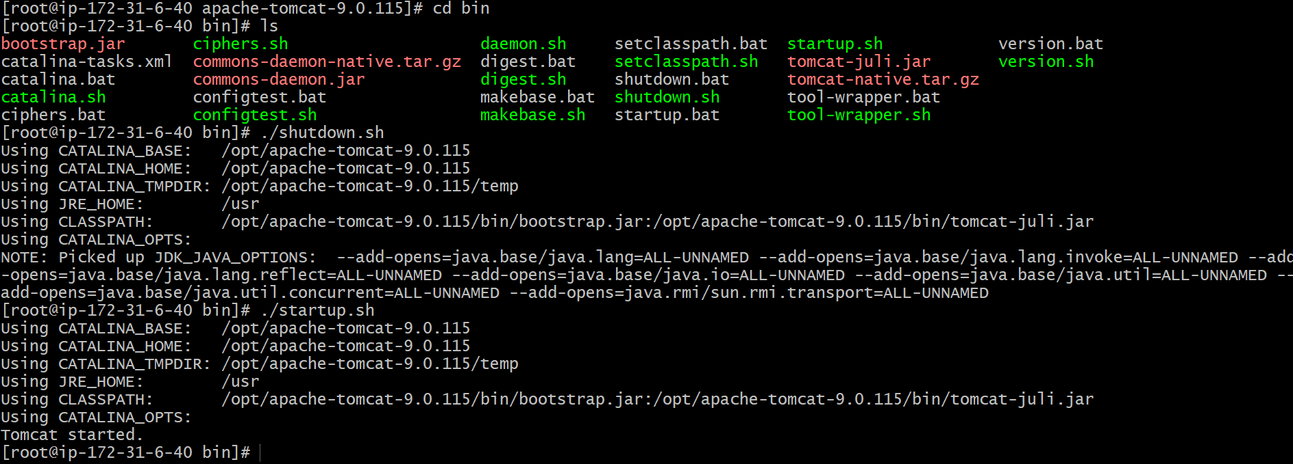

Login to http://<tomcat-public-ip>:8080 >> click server status in tomcat home page

Enter credentials :
Username - deployer
Password - deployer
Login successful , Server Status page loads with JVM and memory details.
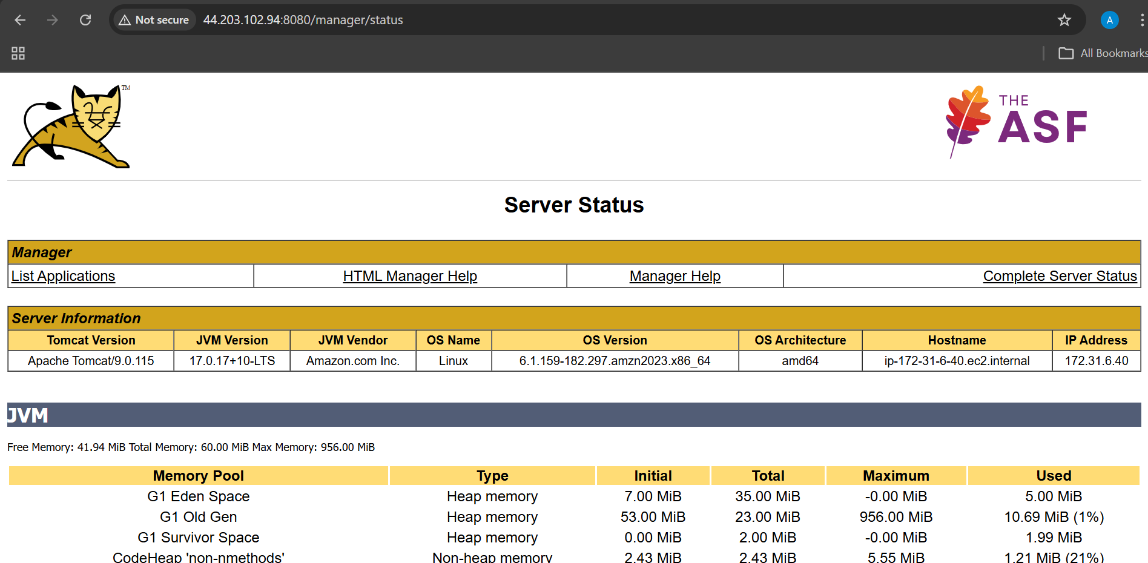

Tomcat installation done and server is ready for integration .

Tomcat deployment :

Open jenkins dashboard
Manage jenkins >> plugins >> available plugins >> deploy to container >> install .
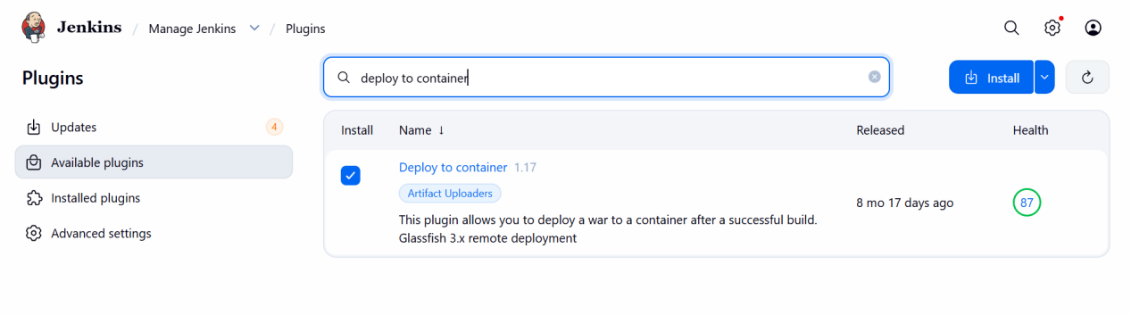

select job >> configure >> add post build action >> deploy war/ear to a container
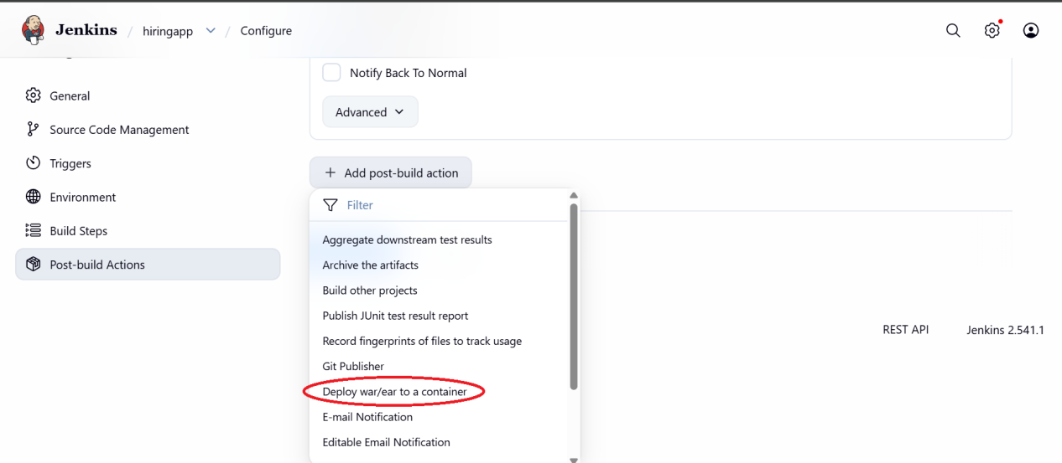

Deply war/ear to a container :

WAR/EAR files : **/*.war
context path : ignore
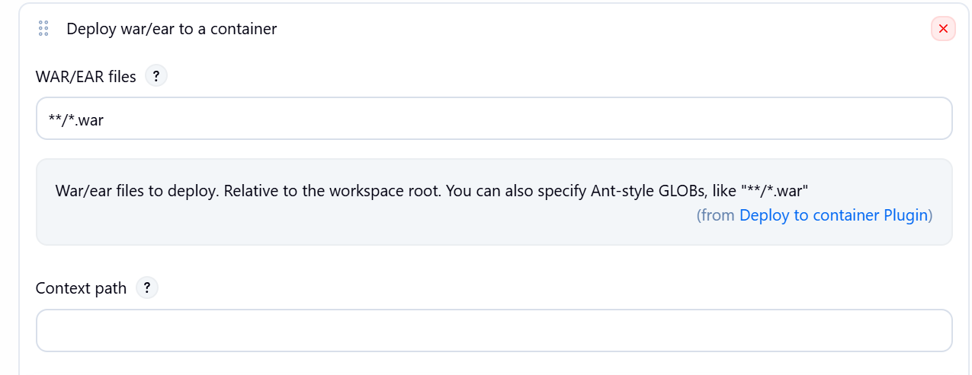

Container : add container tomcat 9x
Credentials : add credentials of tomcat of username and password “deployer” “deployer”
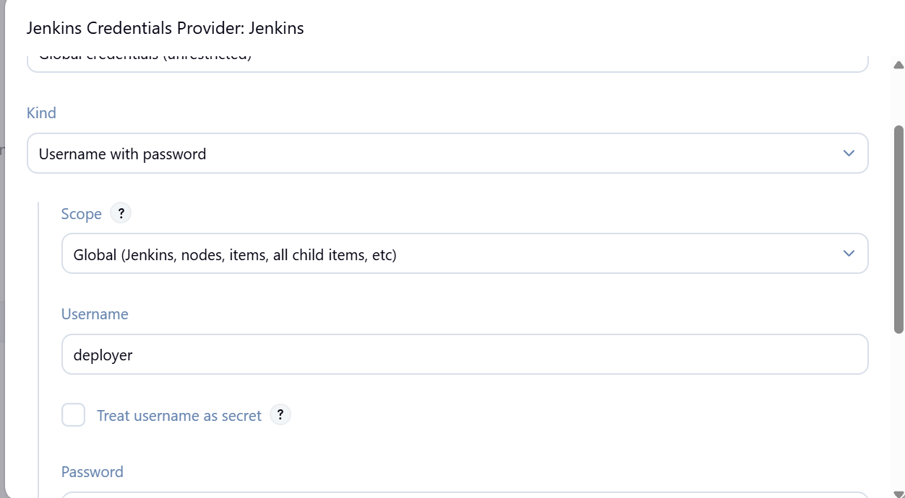

Tomcat url : paste the url of tomcat
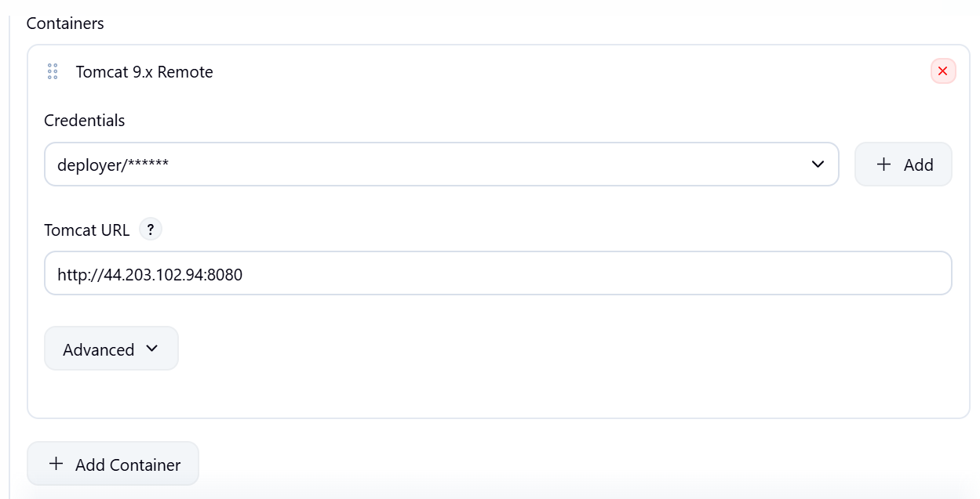

Save and build the job.

3. Validation Steps :

* Open browser:

```
http://<server-ip>:8080/hiring
```
* Application should load successfully

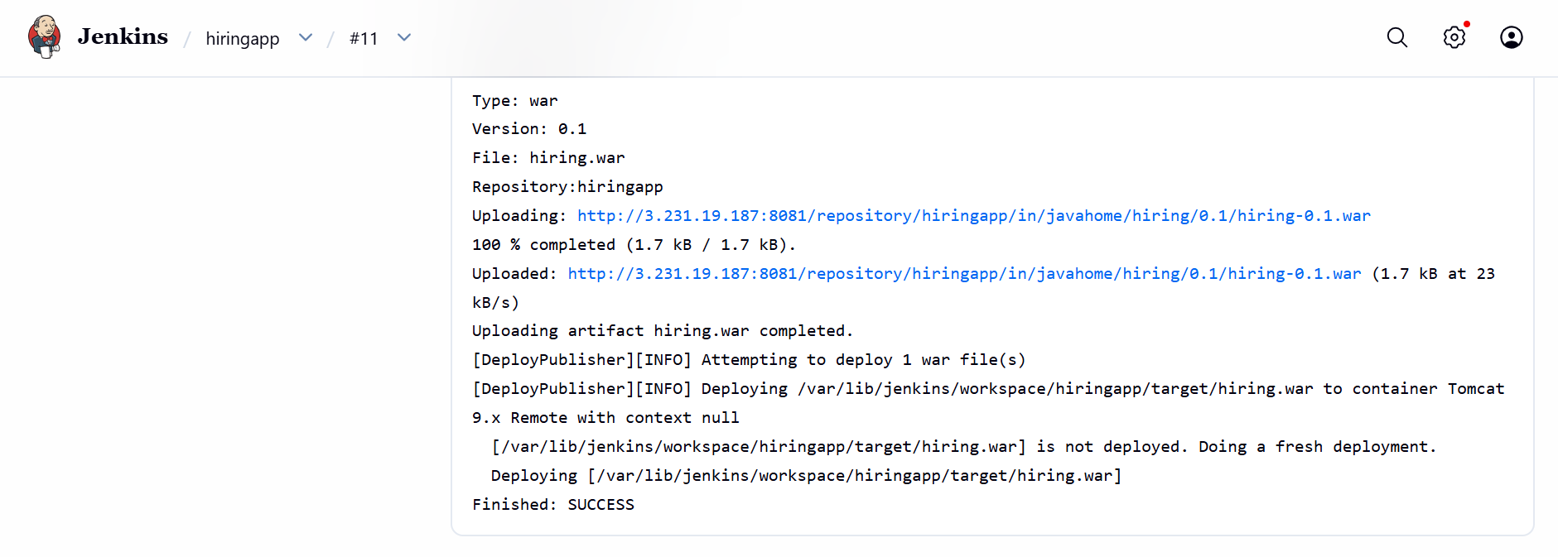

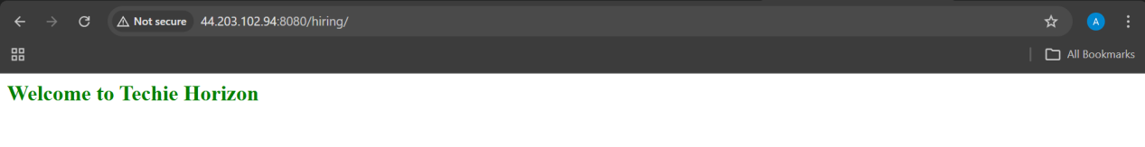

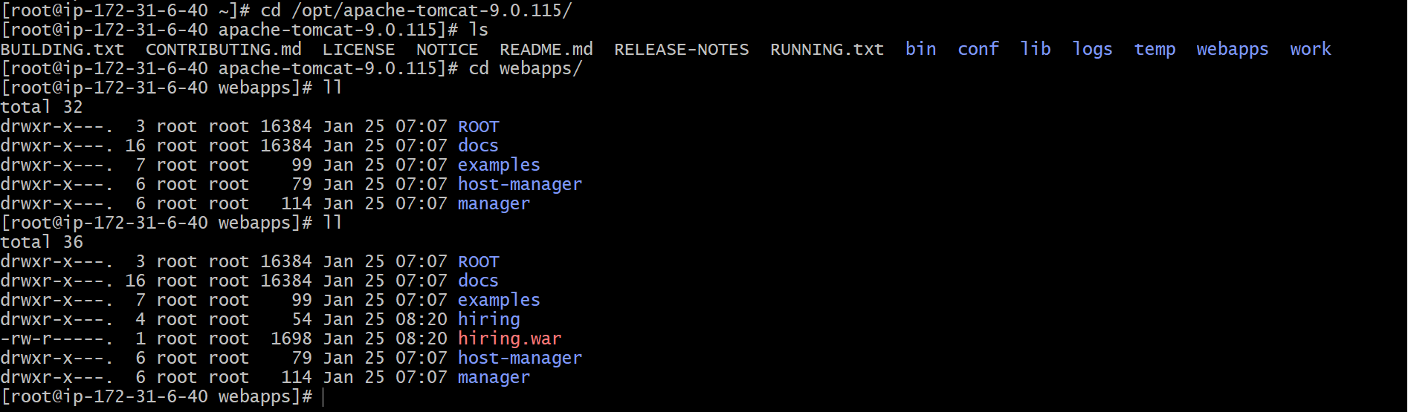

✅ Final CI/CD Flow Summary

Git Clone
↓
SonarQube Analysis
↓
Maven Build
↓
Nexus Upload
↓
Slack Notification
↓
Tomcat Deployment.

- Setup a jenkins CICD pipeline using Declarative pipeline using feature-1.1 branch.
https://github.com/betawins/sabear_simplecutomerapp/tree/feature-1.1
stages:
1) Git Clone
2) Sonarqube Integration
3) Maven Compilation
4) Nexus Artifactory
5) Slack Notification
6) Deploy On tomcat

STAGE 1 : GIT CLONE

1. Prerequisites

* Jenkins installed
* Git installed on Jenkins server
* Jenkins Git plugin installed
* Network access to GitHub
* Repository:
`https://github.com/betawins/sabear_simplecutomerapp.git`
* Branch: `feature-1.1`

2. Step-by-Step Implementation

1. Create a new Jenkins Pipeline job.
2. Configure pipeline.
3. defination: pipeline script

4. Script :

pipeline {
agent any
stages {
stage('Git Clone') {
steps {
git branch: 'feature-1.1',
url: 'https://github.com/betawins/sabear_simplecutomerapp.git'
}
}
}
}

3. Validation Steps

* Check Jenkins console log:
```
Cloning repository...
Branch feature-1.1 checked out
```
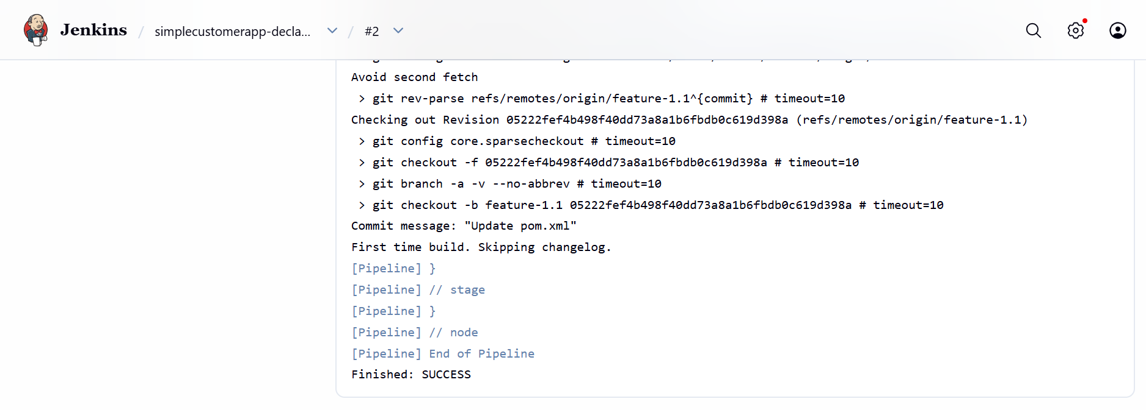
* Workspace should contain `pom.xml`.

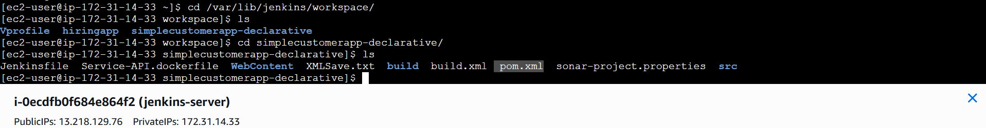

STAGE 2 : SONARQUBE INTEGRATION

1. Prerequisites

* SonarQube server running
* SonarScanner installed on Jenkins
* SonarQube token configured in Jenkins credentials
* SonarQube configured in Jenkins Global Tools
* Project details from pom.xml:

* Project name: `SimpleCustomerApp`
* Java version: 1.8

2. Step-by-Step Implementation

1. Configure SonarQube in Jenkins (Manage Jenkins → Configure System).
2. Add SonarScanner tool.
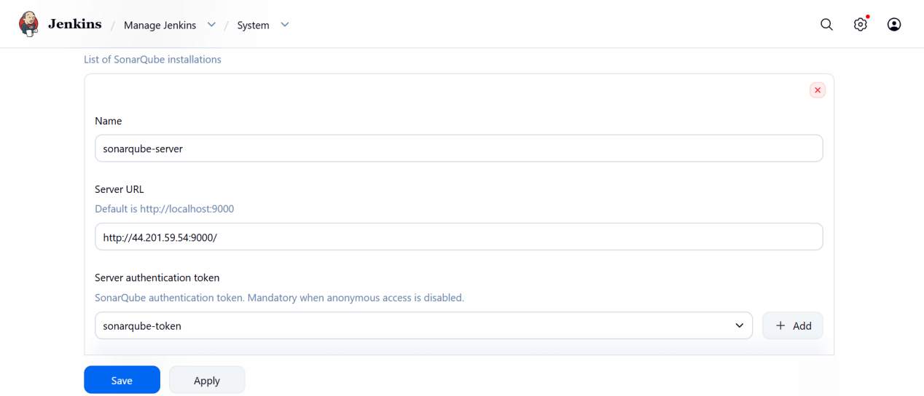
- In jenkins server ----> install java --> sudo dnf install java-17-amazon-corretto-devel -y

Manage jenkins >>tools >> add jdk
Name : jdk17
Java_home : /usr/lib/jvm/java-17-amazon-corretto.x86_64
we can get it from --> readlink -f $(which java)

3. Jenkinsfile stage:

```groovy
pipeline {
agent any
tools {
jdk 'jdk17'
maven 'MVN_HOME'
}
environment {
GIT_URL = "https://github.com/betawins/sabear_simplecutomerapp.git"
GIT_BRANCH = "feature-1.1"
}

stages {
stage('Git Clone') {
steps {
git branch: "${GIT_BRANCH}",
url: "${GIT_URL}"
}
}
stage('SonarQube Analysis') {
environment {
JAVA_HOME= '/usr/lib/jvm/java-17-amazon-corretto.x86_64'
MAVEN_HOME = "/opt/apache-maven-3.9.12"
SONAR_SCANNER_HOME = "/opt/sonar-scanner"
PATH = "${JAVA_HOME}/bin:${MAVEN_HOME}/bin:${SONAR_SCANNER_HOME}/bin:${PATH}"
}

steps {
withSonarQubeEnv('sonarqube-server') {
sh '''
mvn clean verify \
org.sonarsource.scanner.maven:sonar-maven-plugin:sonar \
-Dsonar.projectKey=SimpleCustomerApp \
-Dsonar.projectName=SimpleCustomerApp
'''
}
}
}
}
}
```

3. Validation Steps

* Login to SonarQube UI.
* Verify project `SimpleCustomerApp` exists.
* Check Quality Gate status = Passed.

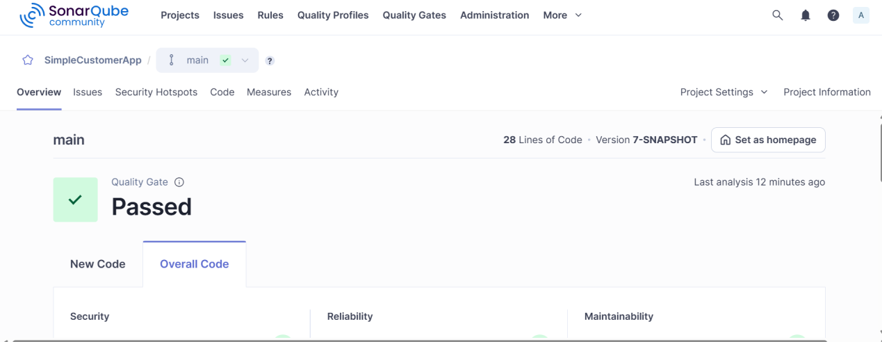

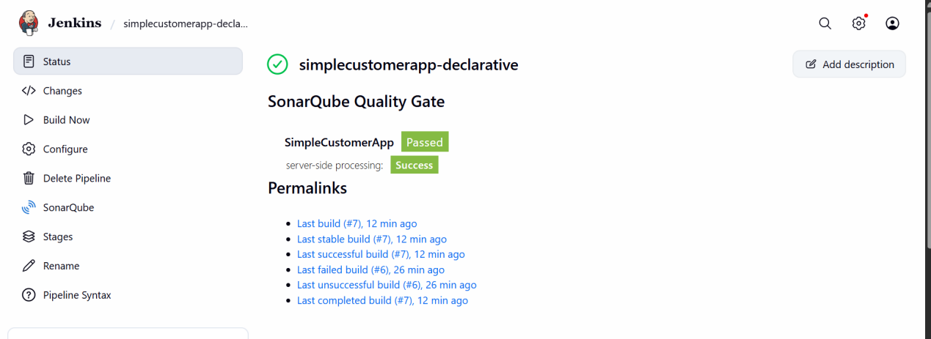

STAGE 3 : MAVEN COMPILATION

1. Prerequisites

* Maven installed in Jenkins
* Java configured
* pom.xml available
* maven-war-plugin present

## 2. Step-by-Step Implementation

1. Jenkinsfile stage:

```groovy
pipeline {
agent any

tools {
jdk 'jdk17'
maven 'MVN_HOME'
}

stages {

stage('Git Clone') {
steps {
git 'https://github.com/betawins/sabear_simplecutomerapp.git'
}
}

stage('SonarQube Analysis') {
environment {
JAVA_HOME = '/opt/apache-maven-3.9.12'
PATH = "$SONARQUBE_HOME/bin:$PATH"
}

steps {
withSonarQubeEnv('sonarqube-server') {
sh '''
mvn clean verify \
org.sonarsource.scanner.maven:sonar-maven-plugin:sonar \
-Dsonar.projectKey=SimpleCustomerApp \
-Dsonar.projectName=SimpleCustomerApp
'''
}
}
}
stage('Maven Build') {
steps {
sh 'mvn clean package'
}
}
}
}
```

2. WAR will be generated using:
```
artifactId = SimpleCustomerApp
version = ${BUILD_NUMBER}-SNAPSHOT
```
## 3. Validation Steps

* Check target folder:

```
target/SimpleCustomerApp-<BUILD_NUMBER>-SNAPSHOT.war
```
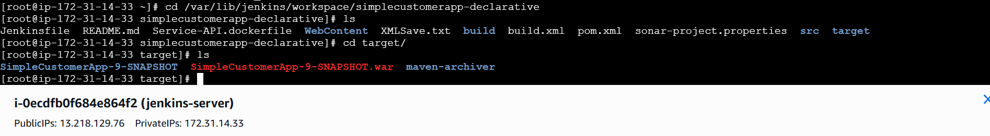
* Console log:

```
BUILD SUCCESS
```
STAGE 4 : NEXUS ARTIFACTORY

1. Step-by-Step Implementation

- create a repository in nexus dashboard
Name : simplecustomerapp .
Version : snapshot .
Layout policy : permissive .
Blob store : defualt .
Deploy policy : allow .
2. Jenkinsfile stage:

```groovy
pipeline {
agent any

tools {
jdk 'jdk17'
maven 'MVN_HOME'
}

stages {

stage('Git Clone') {
steps {
git 'https://github.com/betawins/sabear_simplecutomerapp.git'
}
}

stage('SonarQube Analysis') {
environment {
JAVA_HOME = '/opt/apache-maven-3.9.12'
PATH = "$SONARQUBE_HOME/bin:$PATH"
}

steps {
withSonarQubeEnv('sonarqube-server') {
sh '''
mvn clean verify \
org.sonarsource.scanner.maven:sonar-maven-plugin:sonar \
-Dsonar.projectKey=SimpleCustomerApp \
-Dsonar.projectName=SimpleCustomerApp
'''
}
}
}
stage('Maven Build') {
steps {
sh 'mvn clean package'
}
}
stage('Nexus Upload') {
steps {
nexusArtifactUploader(
nexusVersion: 'nexus3',
protocol: 'http',
nexusUrl: '3.231.19.187:8081',
repository: 'simplecustomerapp',
credentialsId: 'nexus-server',
groupId: 'com.javatpoint',
version: '${BUILD_NUMBER}-SNAPSHOT',
artifacts: [
[artifactId: 'SimpleCustomerApp', type: 'war', file: 'target/SimpleCustomerApp-${BUILD_NUMBER}-SNAPSHOT.war']
]
)
}
}
}
}
```

3. Validation Steps

* Login to Nexus UI.
* Browse repository:
simplecustomerapp
* WAR file should be present.

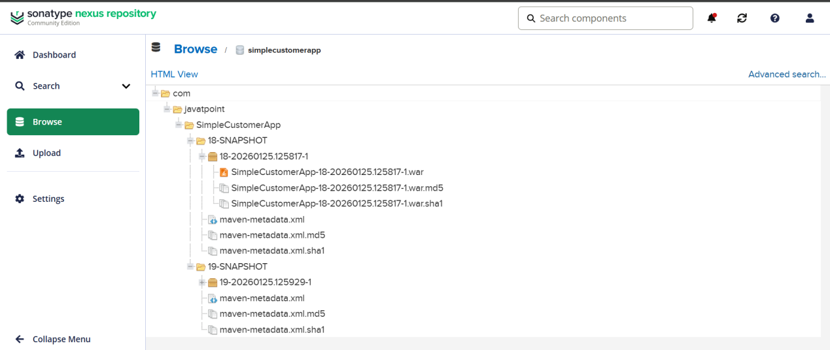

STAGE 5 : SLACK NOTIFICATION

1. Prerequisites

* Slack workspace
* Jenkins Slack plugin installed
* Slack webhook token configured
* Channel created (example: #jenkins-integration)

2. Step-by-Step Implementation

1. Jenkinsfile stage:

```groovy
stage('Slack Notification') {
steps {
slackSend channel: '#jenkins-build',
message: "Build ${env.BUILD_NUMBER} for SimpleCustomerApp completed successfully!"
}
}
```

3. Validation Steps

* Check Slack channel message:

```
Build 15 for SimpleCustomerApp completed successfully!

STAGE 6 : DEPLOY TO TOMCAT

1. Prerequisites

* Tomcat installed and running
* Manager app enabled
* Jenkins credentials for Tomcat
* WAR file generated from Maven build
* Port 8080 open

## 2. Step-by-Step Implementation

- Jenkinsfile server:
Create pemkey on jenkins server at /var/lib/jenkins/.ssh
Chmod 600 pemkey
Chown jenkins:jenkins pemkey

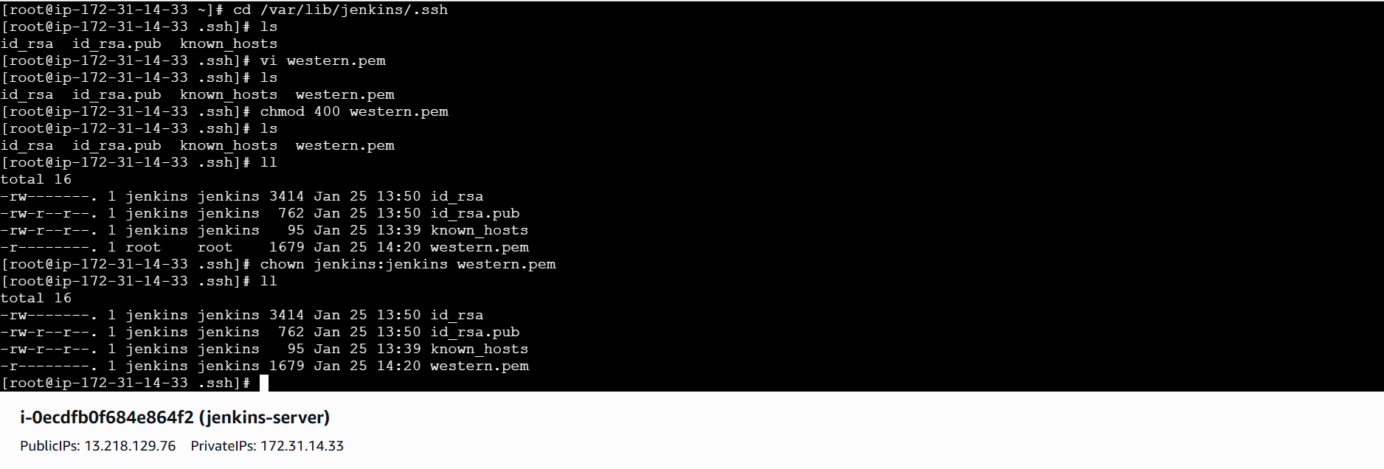
Pipeline :
pipeline {
agent any
tools {
jdk 'jdk17'
maven 'MVN_HOME'
}
environment {
GIT_URL = "https://github.com/betawins/sabear_simplecutomerapp.git"
GIT_BRANCH = "feature-1.1"
}

stages {
stage('Git Clone') {
steps {
git branch: "${GIT_BRANCH}",
url: "${GIT_URL}"
}
}
stage('SonarQube Analysis') {
environment {
JAVA_HOME= '/usr/lib/jvm/java-17-amazon-corretto.x86_64'
MAVEN_HOME = "/opt/apache-maven-3.9.12"
SONAR_SCANNER_HOME = "/opt/sonar-scanner"
PATH = "${JAVA_HOME}/bin:${MAVEN_HOME}/bin:${SONAR_SCANNER_HOME}/bin:${PATH}"
}

steps {
withSonarQubeEnv('sonarqube-server') {
sh '''
mvn clean verify \
org.sonarsource.scanner.maven:sonar-maven-plugin:sonar \
-Dsonar.projectKey=SimpleCustomerApp \
-Dsonar.projectName=SimpleCustomerApp
'''
}
}
}
stage('Maven Build') {
steps {
sh 'mvn clean package'
}
}
stage('Upload to Nexus') {
steps {
nexusArtifactUploader(
nexusVersion: 'nexus3',
protocol: 'http',
nexusUrl: '3.231.19.187:8081',
repository: 'simplecustomerapp',
credentialsId: 'nexus-server',
groupId: 'com.javatpoint',
version: "${BUILD_NUMBER}-SNAPSHOT",
artifacts: [
[ artifactId: 'SimpleCustomerApp', type: 'war', file: 'target/SimpleCustomerApp-${BUILD_NUMBER}-SNAPSHOT.war' ]
]
)
}
}
stage('Deploy on Tomcat') {
steps {

sh '''
scp -i /var/lib/jenkins/.ssh/western.pem \
-o StrictHostKeyChecking=no \
target/SimpleCustomerApp-${BUILD_NUMBER}-SNAPSHOT.war \
ec2-user@44.204.102.81:/opt/apache-tomcat-9.0.115/webapps/
'''
}
}
}
}

3. Validation Steps

* Open browser:

```
http://<tomcat-ip>:8080/SimpleCustomerApp
```
* Application should load successfully.

- Setup a jenkins CICD pipeline using Scripted pipeline using feature-1.1 branch.
https://github.com/betawins/sabear_simplecutomerapp/tree/feature-1.1
stages:
1) Git Clone
2) Sonarqube Integration
3) Maven Compilation
4) Nexus Artifactory
5) Slack Notification
6) Deploy On tomcat

Scripted pipeline :

node {

// Tools
def JAVA_HOME = "/usr/lib/jvm/java-17-amazon-corretto.x86_64"
def MAVEN_HOME = "/opt/apache-maven-3.9.12"
def SONAR_SCANNER_HOME = "/opt/sonar-scanner"

env.PATH = "${JAVA_HOME}/bin:${MAVEN_HOME}/bin:${SONAR_SCANNER_HOME}/bin:${env.PATH}"

def GIT_URL = "https://github.com/betawins/sabear_simplecutomerapp.git"
def GIT_BRANCH = "feature-1.1"

stage('Git Clone') {
git branch: "${GIT_BRANCH}", url: "${GIT_URL}"
}

stage('SonarQube Analysis') {
withSonarQubeEnv('sonarqube-server') {
sh '''
mvn clean verify \
org.sonarsource.scanner.maven:sonar-maven-plugin:sonar \
-Dsonar.projectKey=SimpleCustomerApp \
-Dsonar.projectName=SimpleCustomerApp
'''
}
}

stage('Maven Build') {
sh 'mvn clean package'
}

stage('Upload to Nexus') {
nexusArtifactUploader(
nexusVersion: 'nexus3',
protocol: 'http',
nexusUrl: '3.231.19.187:8081',
repository: 'simplecustomerapp',
credentialsId: 'nexus-server',
groupId: 'com.javatpoint',
version: "${env.BUILD_NUMBER}-SNAPSHOT",
artifacts: [
[
artifactId: 'SimpleCustomerApp',
type: 'war',
file: "target/SimpleCustomerApp-${env.BUILD_NUMBER}-SNAPSHOT.war"
]
]
)
}

stage('Deploy on Tomcat') {
sh '''
scp -i /var/lib/jenkins/.ssh/western.pem \
-o StrictHostKeyChecking=no \
target/SimpleCustomerApp-${BUILD_NUMBER}-SNAPSHOT.war \
ec2-user@44.204.102.81:/opt/apache-tomcat-9.0.115/webapps/
'''
}
}

Create a job >> select as pipeline >>

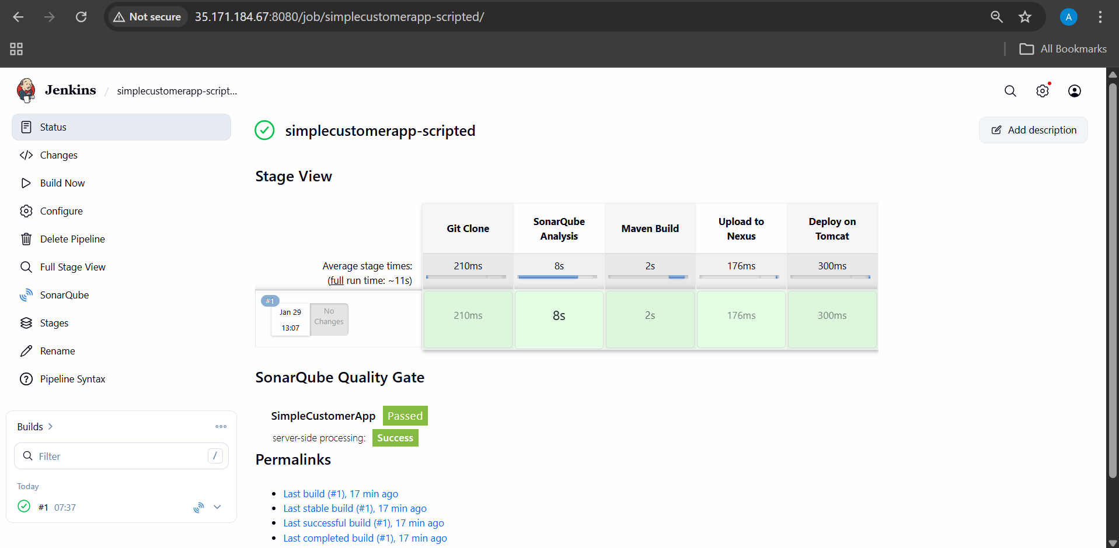

- Write sample skeleton of pipelines.

pipeline {
agent any

environment {
// Define environment variables
APP_NAME = "my-app"
}

tools {
jdk 'jdk17'
maven 'maven-3.9'
}

stages {

stage('Checkout') {
steps {
// Code checkout
git 'https://github.com/example/repo.git'
}
}

stage('Build') {
steps {
// Build step
sh 'mvn clean package'
}
}

stage('Test') {
steps {
// Test step
sh 'mvn test'
}
}

stage('Deploy') {
steps {
// Deploy step
echo "Deploying application..."
}
}
}

post {
success {
echo "Pipeline completed successfully"
}
failure {
echo "Pipeline failed"
}
always {
echo "Pipeline finished"
}
}
}

- Create a parametirized job in jenkins.
https://github.com/betawins/spring3-mvc-maven-xml-hello-world-1.git

1. Prerequisites

List all requirements before starting:

### Jenkins & Plugins

* Jenkins installed and running
* Required plugins installed:

* **Git Plugin**
* **Maven Integration Plugin**
* **Parameterized Trigger Plugin** (usually built-in)

### Tools Configuration (Manage Jenkins → Global Tool Configuration)

* **JDK** configured (example: jdk11 or jdk8)
* **Maven** configured (example: maven-3.9.12)

### Network & Access

* Jenkins server has internet access
* GitHub repo is publicly accessible

### Git Repository

* URL:

```
https://github.com/betawins/spring3-mvc-maven-xml-hello-world-1.git
```

2. Step-by-Step Implementation

### Step 1: Create a Freestyle Job

1. Login to Jenkins
2. Click **New Item**
3. Job name:

```
spring3-mvc-parameterized-freestyle
```
4. Select **Freestyle project**
5. Click **OK**

### Step 2: Enable Parameterized Build

1. Go to job → **Configure**
2. Check ✅ **This project is parameterized**
3. Add parameters:

#### Parameter 1: Git Branch

* Type: **String Parameter**
* Name: `GIT_BRANCH`
* Default Value: `master`
* Description: Branch name to build

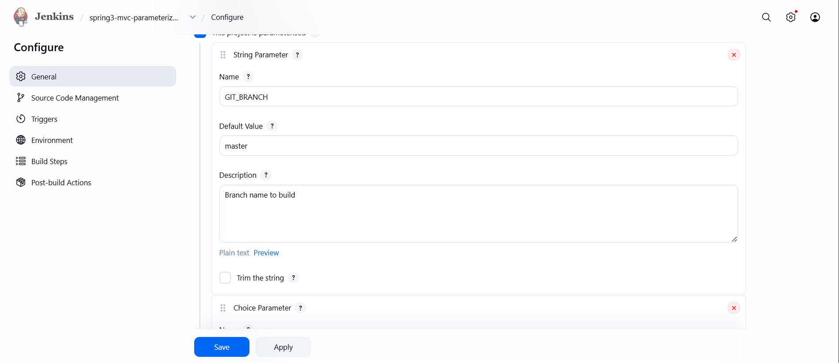

#### Parameter 2: Maven Goal

* Type: **Choice Parameter**
* Name: `MAVEN_GOAL`
* Choices:

```
clean package
clean install
```
* Description: Maven build goal

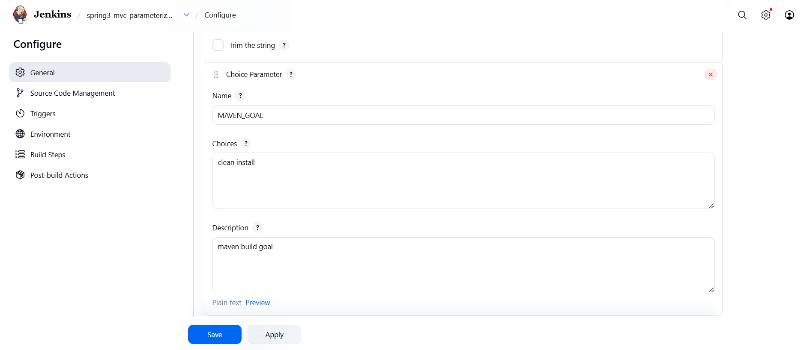

### Step 3: Configure Source Code Management (Git)

1. In **Source Code Management**, select **Git**
2. Repository URL:

```
https://github.com/betawins/spring3-mvc-maven-xml-hello-world-1.git
```
3. Branch Specifier:

```
${GIT_BRANCH}
```
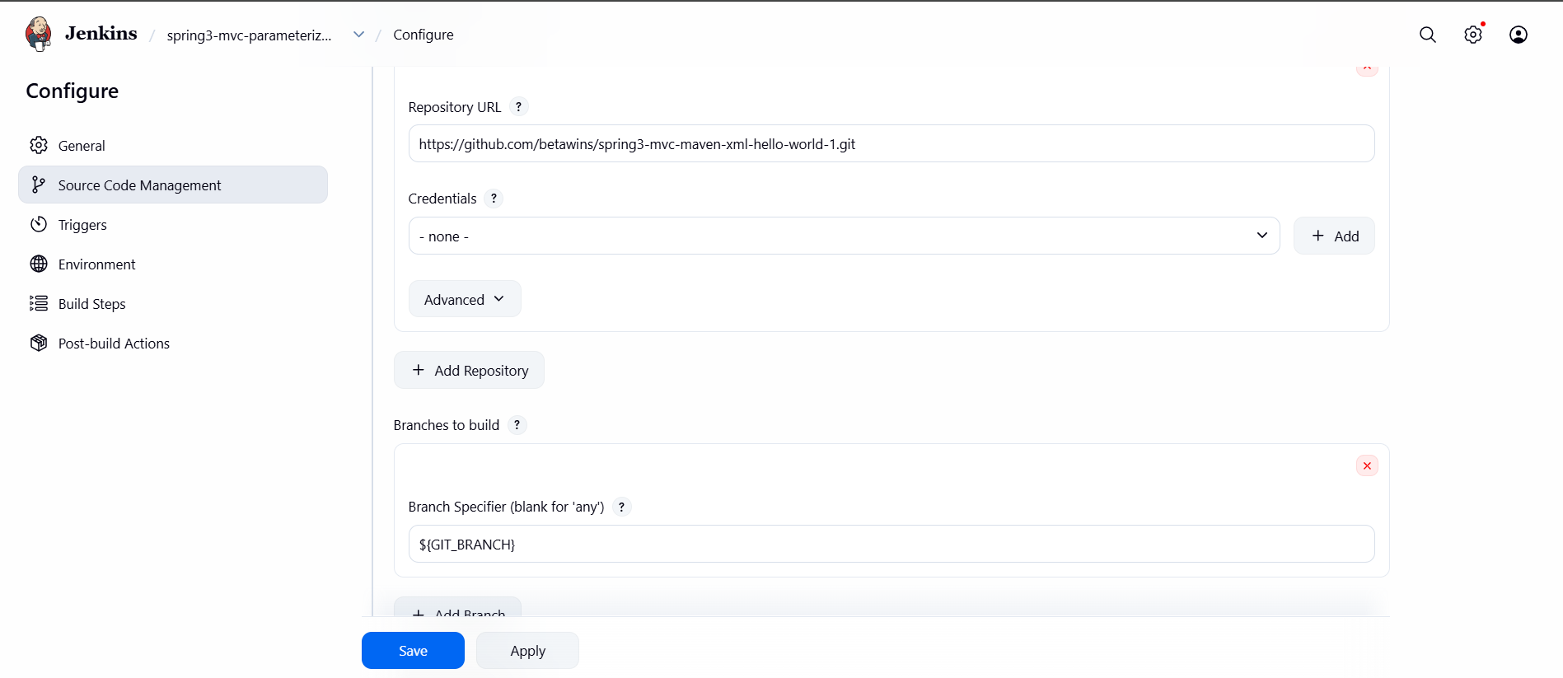

### Step 4: Configure Build Environment

* Check ✅ **Delete workspace before build starts** (optional)
* Select the configured JDK (example: `jdk11`)

---

### Step 5: Add Build Step (Invoke Maven)

1. Under **Build → Add build step**
2. Choose **Invoke top-level Maven targets**
3. Maven Version: `maven-3.9.12`
4. Goals:

```
${MAVEN_GOAL}
```
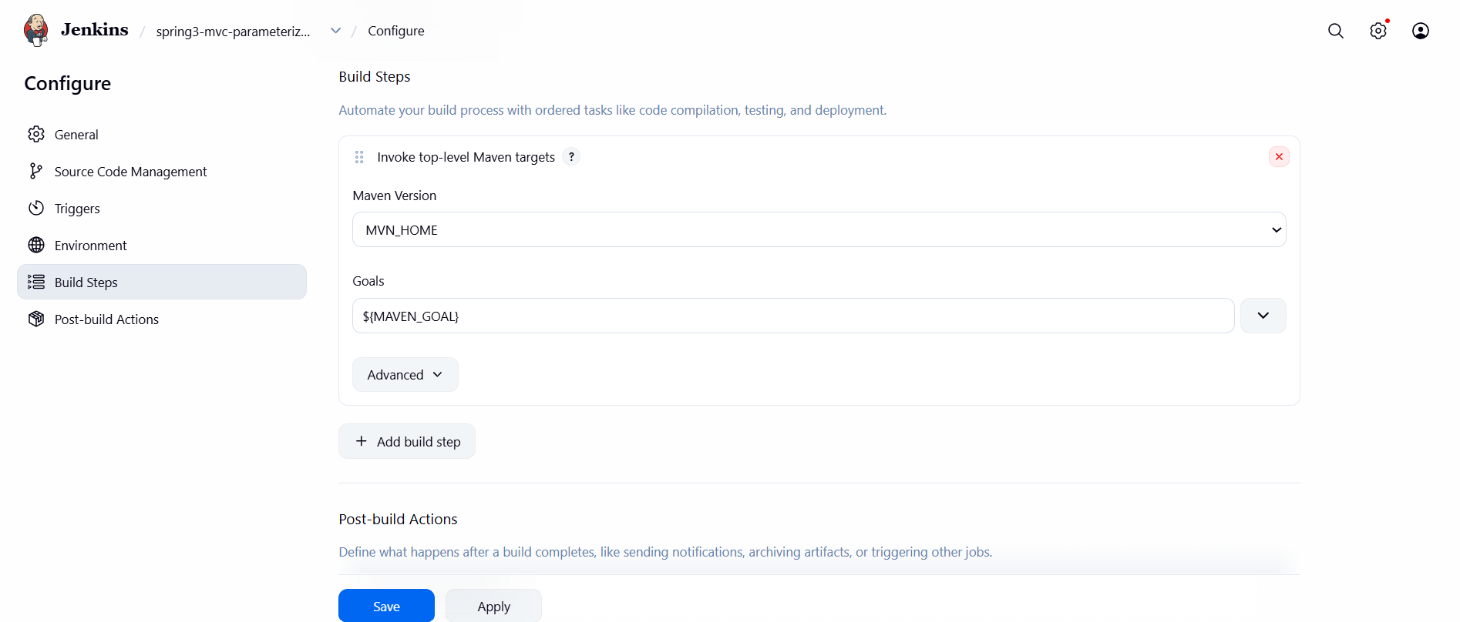

### Step 6: Save the Job

Click **Save**

### Step 7: Build with Parameters

1. Click **Build with Parameters**
2. Enter:

* `GIT_BRANCH = main`
* `MAVEN_GOAL = clean package`
3. Click **Build**

# ✅ 3. Validation Steps

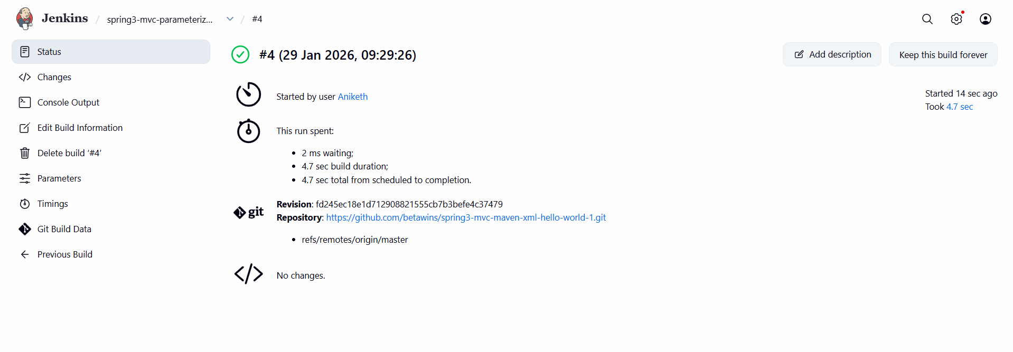

- Setup one slave machine for jenkins.

1. Prerequisites

Before starting, ensure the following are available:

### **Jenkins Master**

* Jenkins installed and running on a master node
* Admin access to Jenkins
* Jenkins URL accessible from slave machines
* Java (JDK 8/11/17) installed

### **Slave (Agent) Machines – 2 Nodes**

* Linux/Windows machines (recommended: Linux)
* Java installed (`java -version`)
* Network connectivity to Jenkins master (port **8080** or configured port)

### **Jenkins Plugins**

* **SSH Build Agents Plugin** (Manage Jenkins → Plugins → Available)

2. Step-by-Step Implementation

### **Step 1: Install Java and create “ssh-keygen” on Both Slave Machines**

```bash
sudo yum update -y
sudo dnf install java-17-amazon-corretto -y
java -version

Create ssh-keygen
cat id_rsa.pub > authorized_keys (this command used to add the “ssh-keygen” to “authorized_keys” )
chmod 700 authorized_keys
```
SLAVE-1

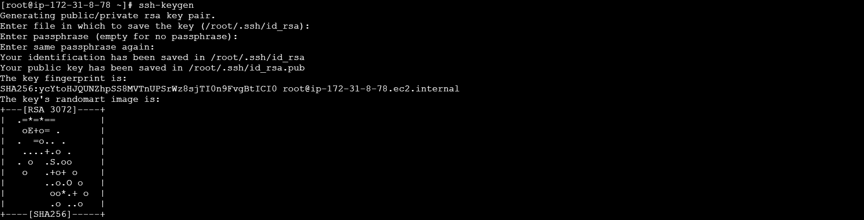
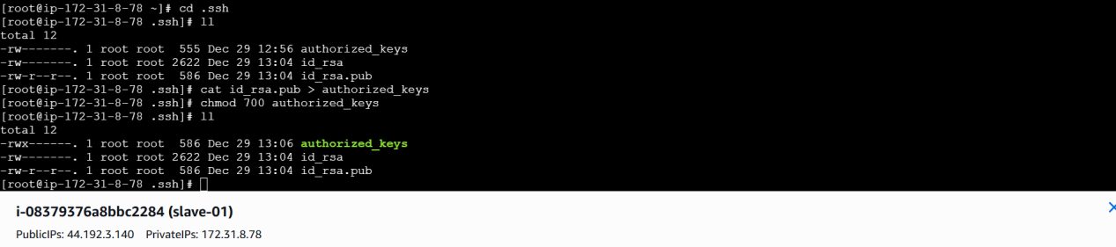

SLAVE-2

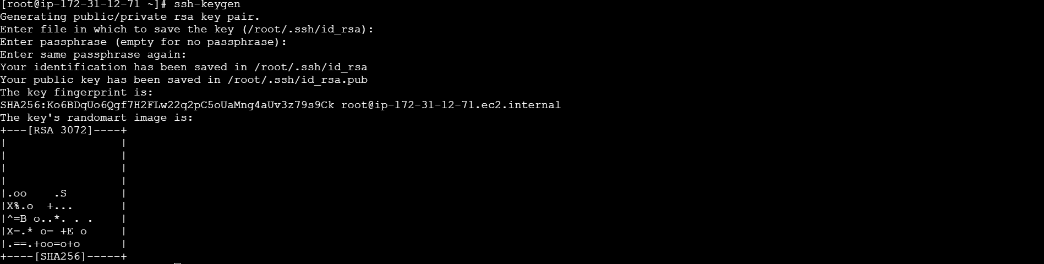
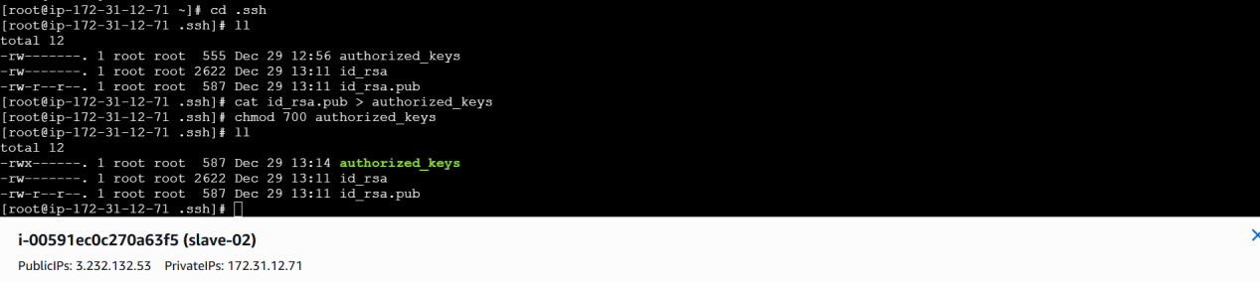

### **Step 2: Login to jenkins master machine**

##CREATE A DIRECTORY “.ssh” in /var/lib/jenkins

mkdir -p /var/lib/jenkins/.ssh
cd /var/lib/jenkins/.ssh

##The below command is used to copy the authorized_keys of the host or ip to known_hosts from both slaves.

ssh-keyscan -H (SLAVE-NODE-IP-OR-HOSTNAME) >>/var/lib/jenkins/.ssh/known_hosts

##we need to change the owner as we ran ssh-keyscan command using “root” user, default user of Jenkins will be “jenkins”

chown jenkins:jenkins known_hosts

chmod 700 known_hosts (giving permissions)
```
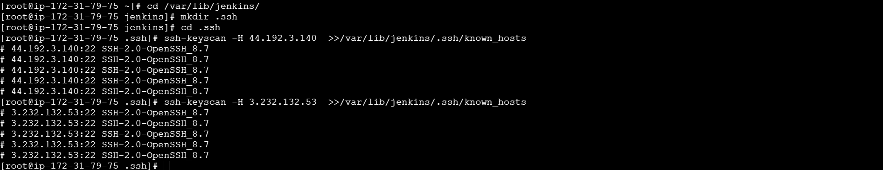
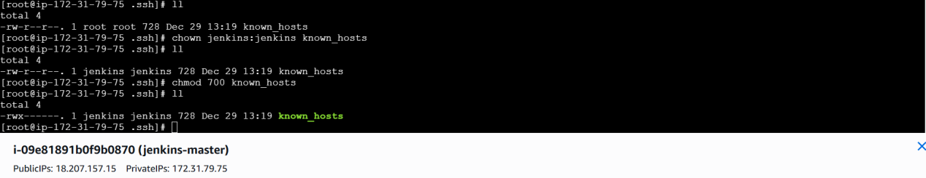

### **Step 5: Configure Jenkins Node (Agent 1)**

1. Go to **Jenkins Dashboard**
2. Click **Manage Jenkins → Nodes and Clouds**
3. Click **New Node**
4. Enter:

* Node name: `agent-1`
* Type: **Permanent Agent**
5. Configure:

* **Remote root directory**: `/home/ec2-user`
* **Labels**: optional
* **Usage**: Use this node as much as possible
* **Launch method**: Launch agents via SSH
* **Host**: `<slave1-ip>`
* **Credentials**: Add SSH credentials
6. Click **Save**

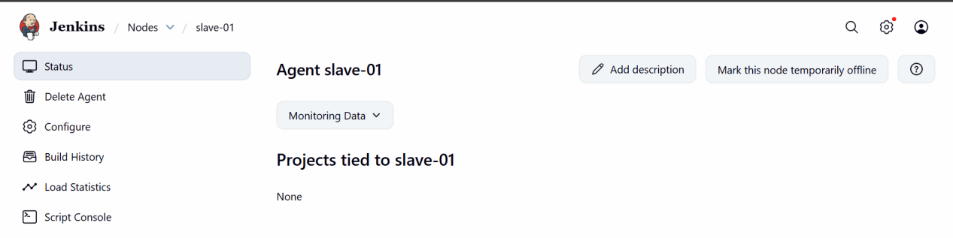

### **Step 6: Configure Jenkins Node (Agent 2)**

Repeat the same steps for **agent-2**:

* Node name: `agent-2`
* Host: `<slave2-ip>`

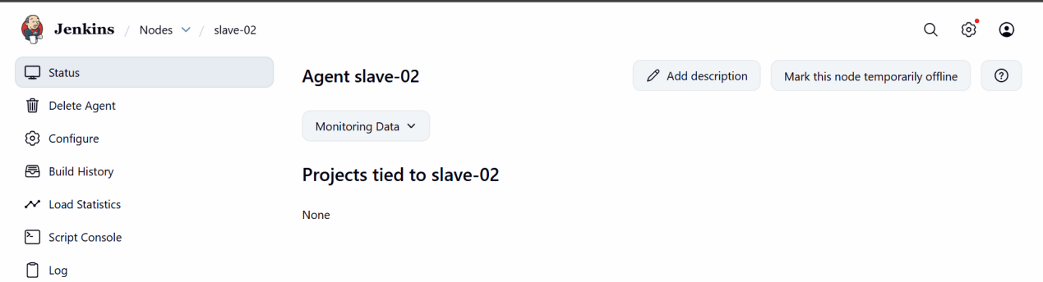

### **Step 7: Verify Agent Connection**

* Go to **Manage Jenkins → Nodes**
* Both agents should show **Connected / Online**

